Game and level Design 2019/2020

GAME AND LEVEL DESIGN - LEVEL DESIGN DOCUMENT

THE DEMOGORGON’S LAIR

Maurizio Lu - 943827

Nicolò Buganza – 961149

Deborah Leonardi - 935754

Matteo Malorgio - 931487

Alessandro Compagnoni – N/A

Special thanks to:

Jacopo Castiglioni (Concept Artist)

**DISCLAIMER**

**This document is not intended for the public. The rights of the images shown in it, if not original works, belong to their respective owners.**

**CHANGELOG**

|  |  |  |
| --- | --- | --- |
| Who | When | What |
| The Eleventh Dice | 21/10/2019 | Document created and writing of first ideas |
| Maurizio, Nicolò | 24/10/2019 | Document Formatting |
| Maurizio | 30/10/2019 | Narrative elements added |
| The Eleventh Dice | 31/10/2019 | Look & Feel added |
| Deborah | 02/11/2019 | Settings added |
| Deborah, Maurizio | 03/10/2019 | High concept (story, game) added |
| Maurizio | 04/10/2019 | Goal outline added |
| Matteo, Alessandro | 05/11/2019 | Story flowchart, world diagram added |
| Deborah, Nicolò | 06/11/2019 | Characters, themes added |
| The Eleventh Dice | 07/11/2019 | Document revision for first milestone |
| Matteo | 27/11/2019 | Minor revisions from first milestone |
| The Eleventh Dice | 28/11/2019 | Document revision for second milestone |

Contents

**1. High concept** 51.1 High level concept (game) 4

1.2 High level concept (story) 4

**2. Settings** 62.1. Hawkins Middle School (Tutorial Level) 6

2.2. Hawkins National Laboratory 6

2.3. The Mirkwood 7

2.4. The Junkyard 7

2.5. Will’s House 8

2.6. The Demogorgon’s Lair (Hawkins Public Library) 9

**3. Synopsis of the story** 10

**4. Story flowchart**11

**5. Themes**13

**6. Characters**14

6.1. Bad Eleven 14

6.1.1. Description 14

6.1.2. Circumplex 14

6.1.3. Map of the relations with other characters 15

6.2. Good Eleven 16

6.2.1. Description 16

6.2.2. Circumplex 17

6.2.3. Map of the relations with other characters 18

6.3. Demogorgon 198

6.3.1. Description 18

6.3.2. Circumplex 19

6.3.3. Map of the relations with other characters 19

6.4. Kali Prasad (8) 20

6.4.1. Description 20

6.4.2. Circumplex 21

6.4.3. Map of the relations with other characters 22

6.5. Raiden (1) 22

6.5.1. Description 22

6.5.2. Circumplex 23

6.5.3. Map of the relations with other characters 24

6.6. Guilherme (9) 25

6.6.1. Description 25

6.6.2. Circumplex 25

6.6.3. Map of the relations with other characters 26

6.7. Catinca (3) 27

6.7.1. Description 27

6.7.2. Circumplex 27

6.7.3. Map of the relations with other characters 28

6.8. Abazu (7) 29

6.8.1. Description 29

6.8.2. Circumplex 30

6.8.3. Map of the relations with other characters 31

6.9. Zasha (5) 32

6.9.1. Description 32

6.9.2. Circumplex 33

6.9.3. Map of the relations with other characters 34

**7. World Diagram** 36

**8. Goal Outline** 38

8.1. Hawkins Middle School38

8.2. Hawkins Laboratory, Upper Floors 38

8.3. Mirkwood 38

8.4. The Junkyard 38

8.5. Will's House and Castle Byers 39

8.6. The Demogorgon's Lair 39

8.7. Real Hawkins 39

8.8. Hawkins Laboratory, Lower Floors 40

**9.** **Look & Feel** 41

**10. Level Story** 46

# 1. High concept (max 250 words)

## 1.1 High level concept (game)

The game is a single player 3D first person adventure game, based on the Netflix series *Stranger Things*. The protagonist of the journey is an evil copy of Eleven (Bad Eleven, B11 from now on) generated from the energy created during the fight between the real Eleven (Good Eleven, G11 from now on) and the Demogorgon, the main antagonist of the series until the end of the first season. See section 6 for more details.

The game consists of a sequence of eight chapters and a tutorial. The first and last will mostly require exploration, whereas the central chapters will be characterized by a miniboss and composed by a series of levels. The main tasks required to the player are exploration and puzzle solving in order to find, acquire and learn new skills and powers (super-speed, mind-control, etc...) from other children living in the Upside Down (see section 1.2). Some of those powers are useful, but most of them are compulsory in order to advance within the game. In order to acquire them, the player must find a special object, linked to the children’s past and to the real world (like Eleven’s puppet), which will trap the child’s soul once they are dead. When they are killed, the children turn into sand and enter the object the player has found.

## 1.2 High level concept (story)

After the defeat of the Demogorgon, two copies of Eleven wake up in the Upside Down. G11 easily passes the gate and goes back to the real world, but B11 remains stuck in the Upside Down, because she, like everything else there, is a copy of something already existing in the actual world. She decides to move to Hawkins Laboratory, to try to pass the gate G11 opened at the beginning of the series and that should still be there. She can’t reach the gate, but she discovers that some of the other children involved in the experiments generated copies like her, that are living in the Upside Down, and she decides to try to take their powers in order to track G11, kill her and take her place in the real world.

She manages to kill a few, but she starts to feel guilty, especially because she can hear the thoughts of the dead children and see their past and their sufferings. She finds out that the last child she has to kill is a little girl who can control the minds of every creature she encounters, and she knows that she needs to befriend her and betray her. As they become friends, B11 feels more and more guilty, until the other children push her to kill the girl. Having acquired the last power needed, B11 controls the Demogorgon to reach the gate in the Laboratory but she still can’t pass it. She understands that she needs to kill G11 in order to do so, so she passes the gate in the body of the Demogorgon, finds G11 and lures her into the Upside Down.

Being a copy, B11’s powers are much weaker than the powers of G11. During the last fight, B11 understands this and enters the mind of the Demogorgon, only to see herself killed by G11. The last things she sees are the souls of the trapped children being freed from the objects and her body turning into sand to join them. Together, they become the Mind Flayer.

# 2. Settings (max 250 words)

All the events take place in Hawkins. The player will not be able to move freely on the map, but he will have to follow the linear structure of the game. However, the map has been designed in order to make the locations look as close as possible to one another.

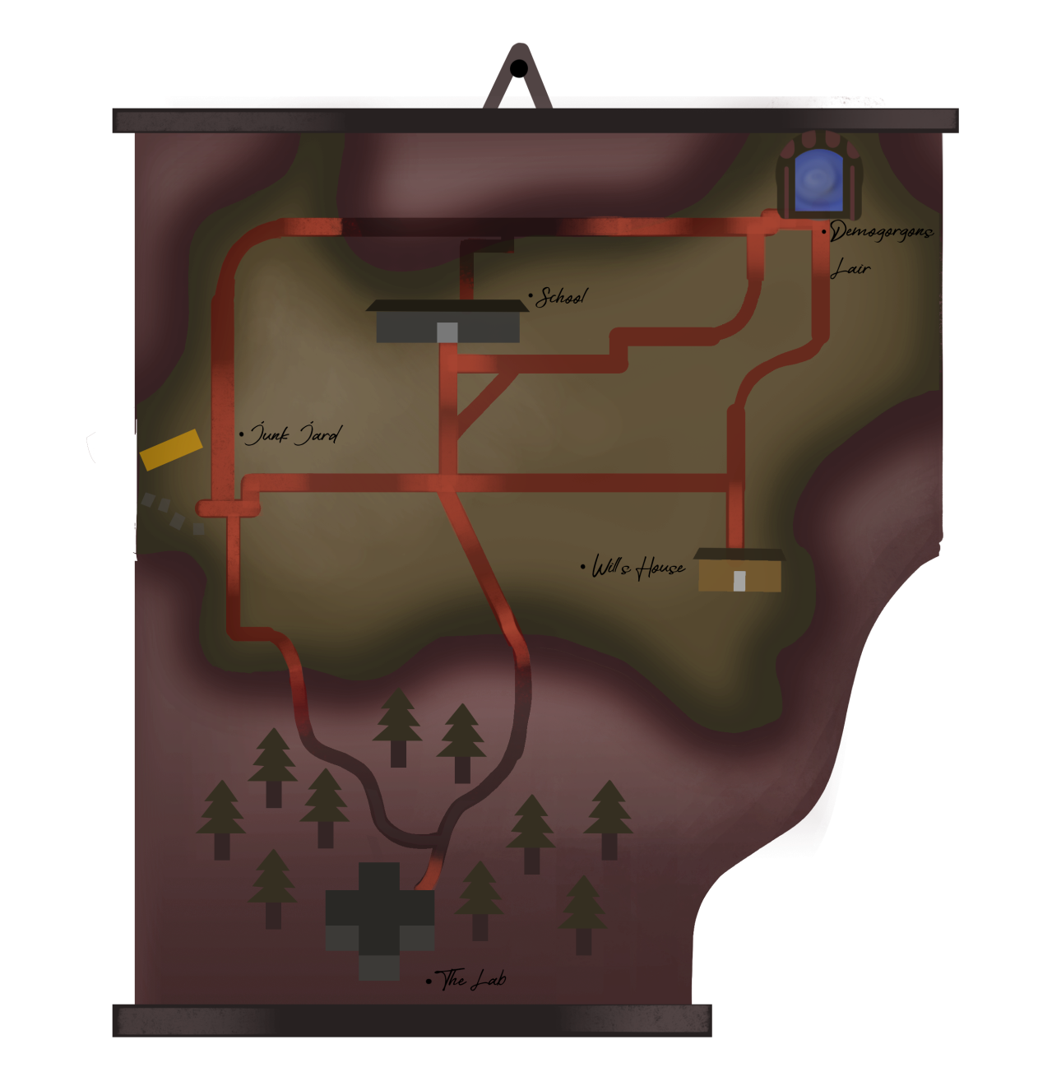

## 2.1. Hawkins Middle School (Tutorial Level)

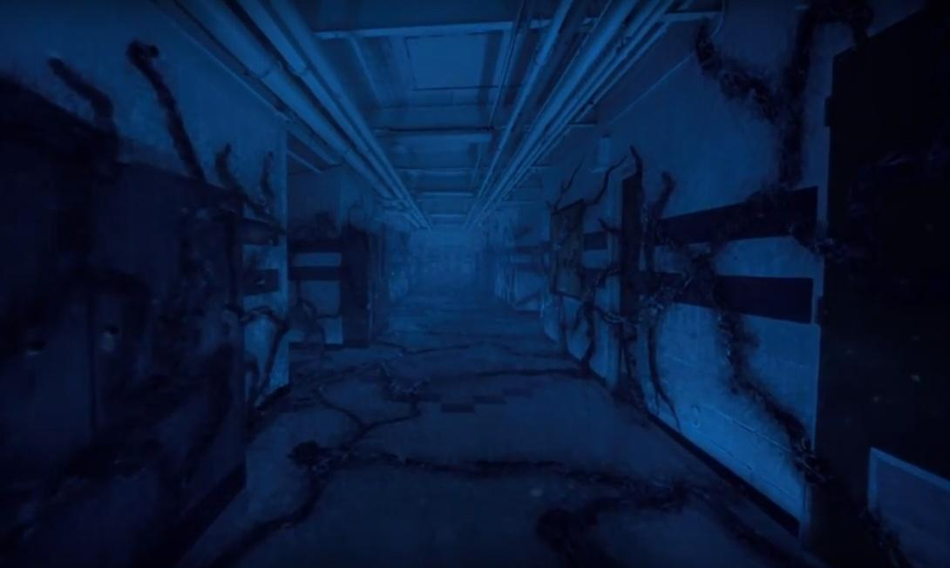

(Screenshot from *Stranger Things*, season 2, episode 2)

Since, as seen in season two of the series, Eleven finds herself in the Upside Down version of Hawkins MIddle School, it is fair to think that the bad copy would also appear there. As the game begins, this is the place where B11 sees G11 for the first time, and where she finds out she needs to find another gate to get to the real world. The player can have a tutorial of the game’s dynamics while trying to get out of the school.

## 2.2. Hawkins National Laboratory

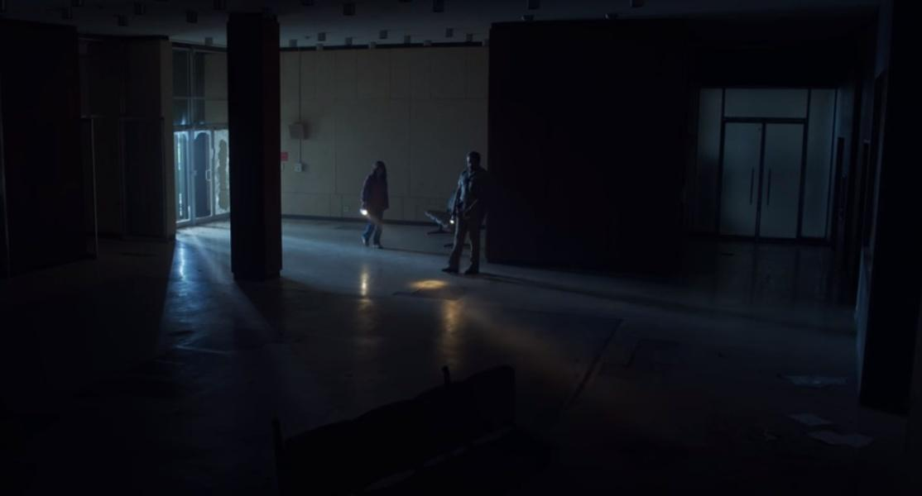

(Screenshot of the Laboratory Hall from *Stranger Things*, season 3, episode 3)

The Laboratory is run by the Department of Energy and is located south of the town of Hawkins. It has seven floors, three of which underground. The hall and the ground floor are the locations of the first introductory chapter. The second chapter will take place in the floors above, whereas the final one will be set underground. At the fourth floor the player will find the first boy, Raiden, and will have a chance of testing his superpower after killing him. There will be a special room, the Rainbow Room, which, if opened, will unlock a special character: Kali.

## 2.3 The Mirkwood

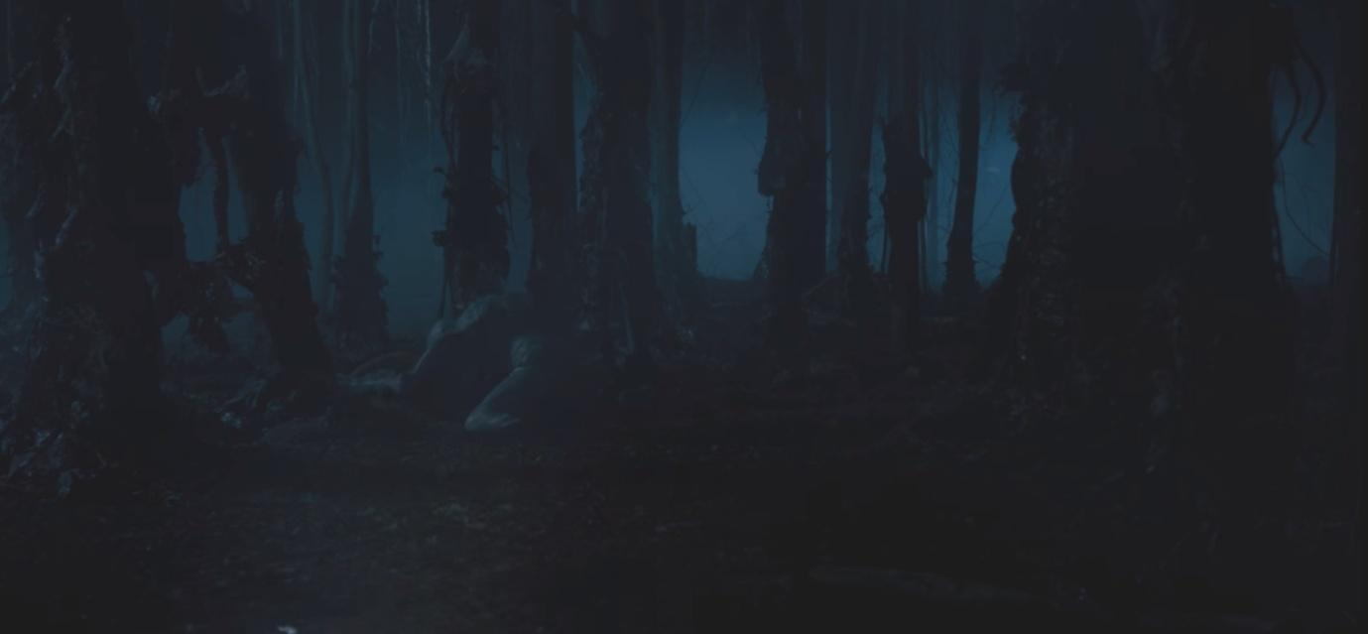

(Screenshot from *Stranger Things* season 1, episode 5)

Mirkwood is the name the protagonists of the series have given to the woods outside of the Laboratory, in which the Demogorgon hunts. It is very dark and it looks like a maze. Here the player will have to find Guilherme, a boy who can control fire. They will also be able of burning trees for testing the ability after having learnt it.

2.4. The Junkyard

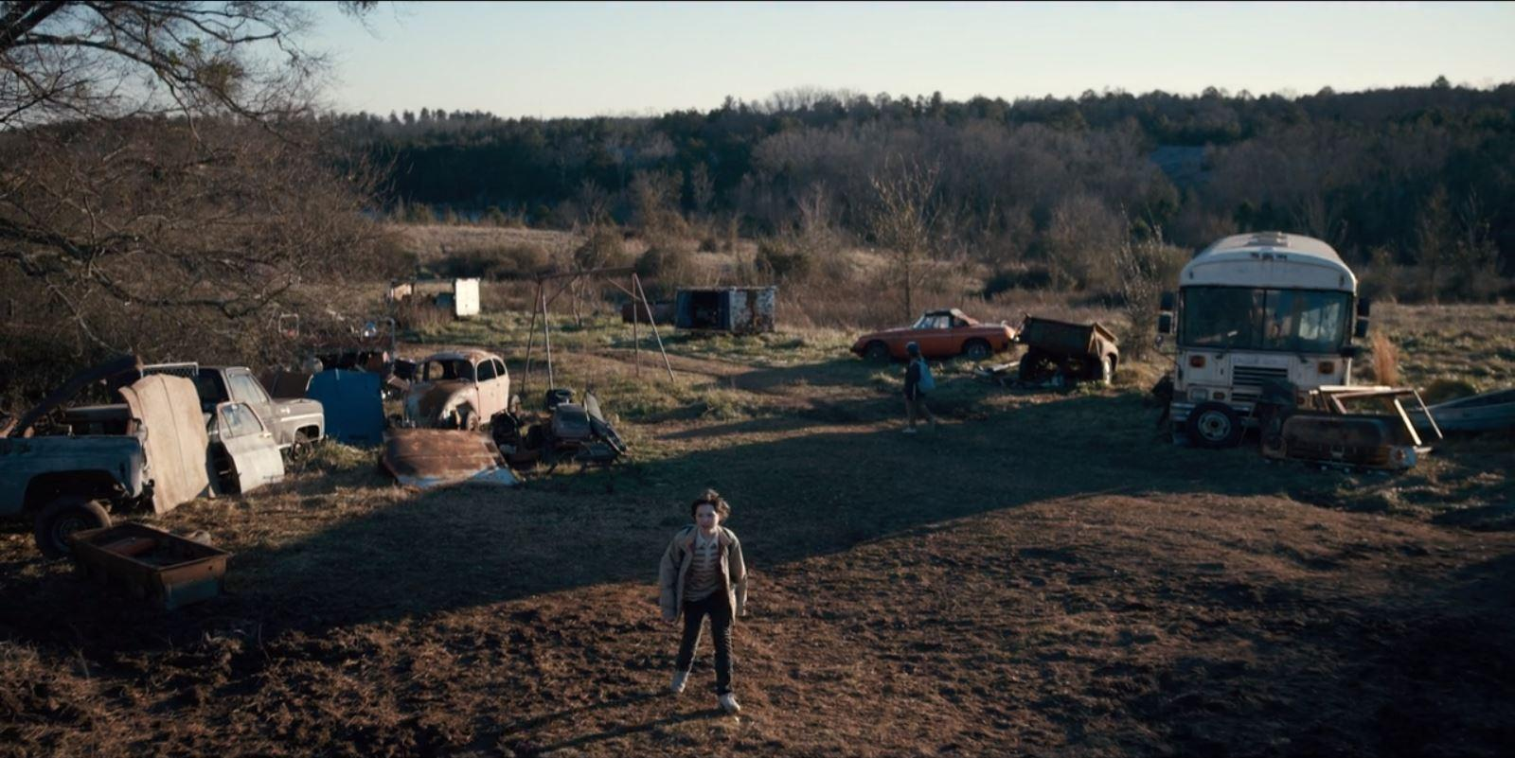

(Picture from Google Images)

The Junkyard is a safe place for the protagonists of the series, but it will be dangerous, dark, and full of monsters in the game. The player will have to fight Catinca, a girl with the power of levitation, but in order to reach her they must avoid a series of traps and monsters looking for them. While solving the puzzles, moreover, the player has to be careful not to be seen by the girl, hiding in the broken bus.

2.5. Will’s House and Castle Byers

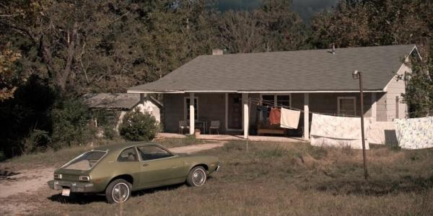

(Picture from *Stranger Things* Wiki)

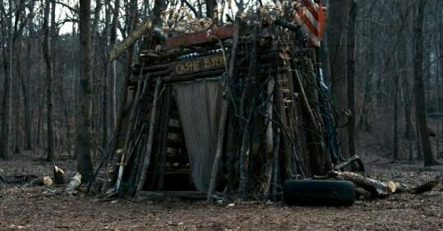

(Picture found on Google Images)

Byers House is quite small and only has one floor. It has a living room, a kitchen, a small hallway which leads to the bedrooms. In the living room the player will face a puzzle with the famous lights seen in the show. They will also be able to explore the garage and Castle Byers, the small construction Will and his brother built in the woods near the house. In order to kill the child living here, Abazu, the player must attract him out of the house to investigate about his powers and then shoot him from afar, with a rifle placed in the garage.

## 2.6. The Demogorgon’s Lair (Hawkins Public Library)

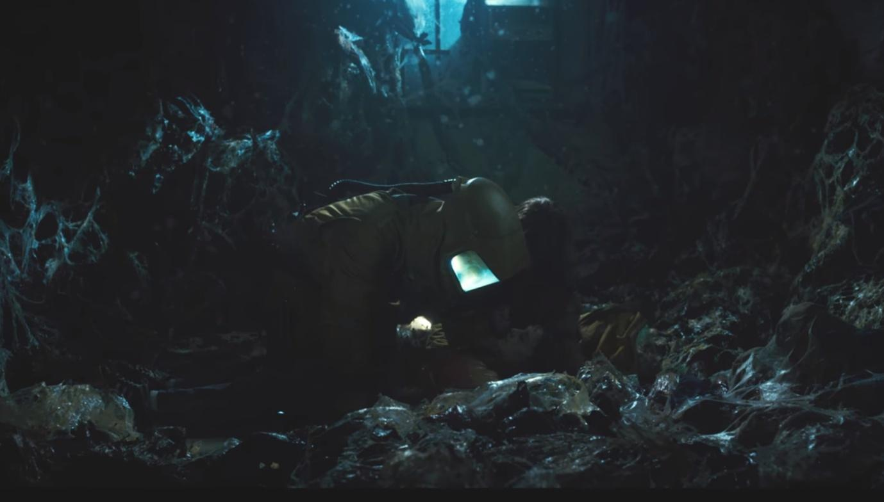

(Screenshot from *Stranger Things* season 1, episode 8)

The Demogorgon lives in the Upside Down version of the Hawkins Public Library. While only the ground floor is shown in the series, in the game the first floor and the underground will be available too. Once entered, the player will see the bodies the Demogorgon has caught and a little girl, Zasha, crouched in the corner, untouched by the monster. In order to befriend her, the player must carry out some tasks in the basement. Once B11 and Zasha are friends, they will move to the upper floor of the Library and tell each other stories of their past. Here B11 will stab Zasha to death and get her power. The Demogorgon, sensing blood, will arrive, and B11 will have to control its mind in order to save herself.

3. Synopsis of the story

The story is divided in three acts.

First Act: B11 is generated in the Upside Down - the death of Catinca

B11 arrives in the Upside Down, decides that she wants to get out and return in the real world (of which she has only the memories she shares with G11) and begins her journey. She finds out that there are other children like her and realizes that she could take their powers to defeat G11.

Second Act: the death of Catinca - the death of Zasha

After killing Catinca, B11 begins to regret what she has done. She thinks that she had no right to kill the others and she starts to wonder how G11 feels like, being good and living a peaceful life out of the Upside Down. When she befriends Zasha, she feels important and trusted by someone for the first time, until the other children she killed remind her that she must finish what she began if she truly wants to get out of the hell she is living in. She lets them get to her head and kills Zasha, which causes her a great pain.

Third Act: the death of Zasha - B11 dies and becomes the Mind Flayer

Having killed her only friend, B11 is now determined to get to the real world, even if this means killing her other half to take her place. She can now control the Demogorgon and using his body she attracts G11 in the Upside Down to kill her. However, she is too weak and is killed. Her soul merges with the souls of the other children and becomes the Mind Flayer, seeking revenge for everything they have been through by the only way possible: destroying everything and everyone.

# 4. Story flowchart

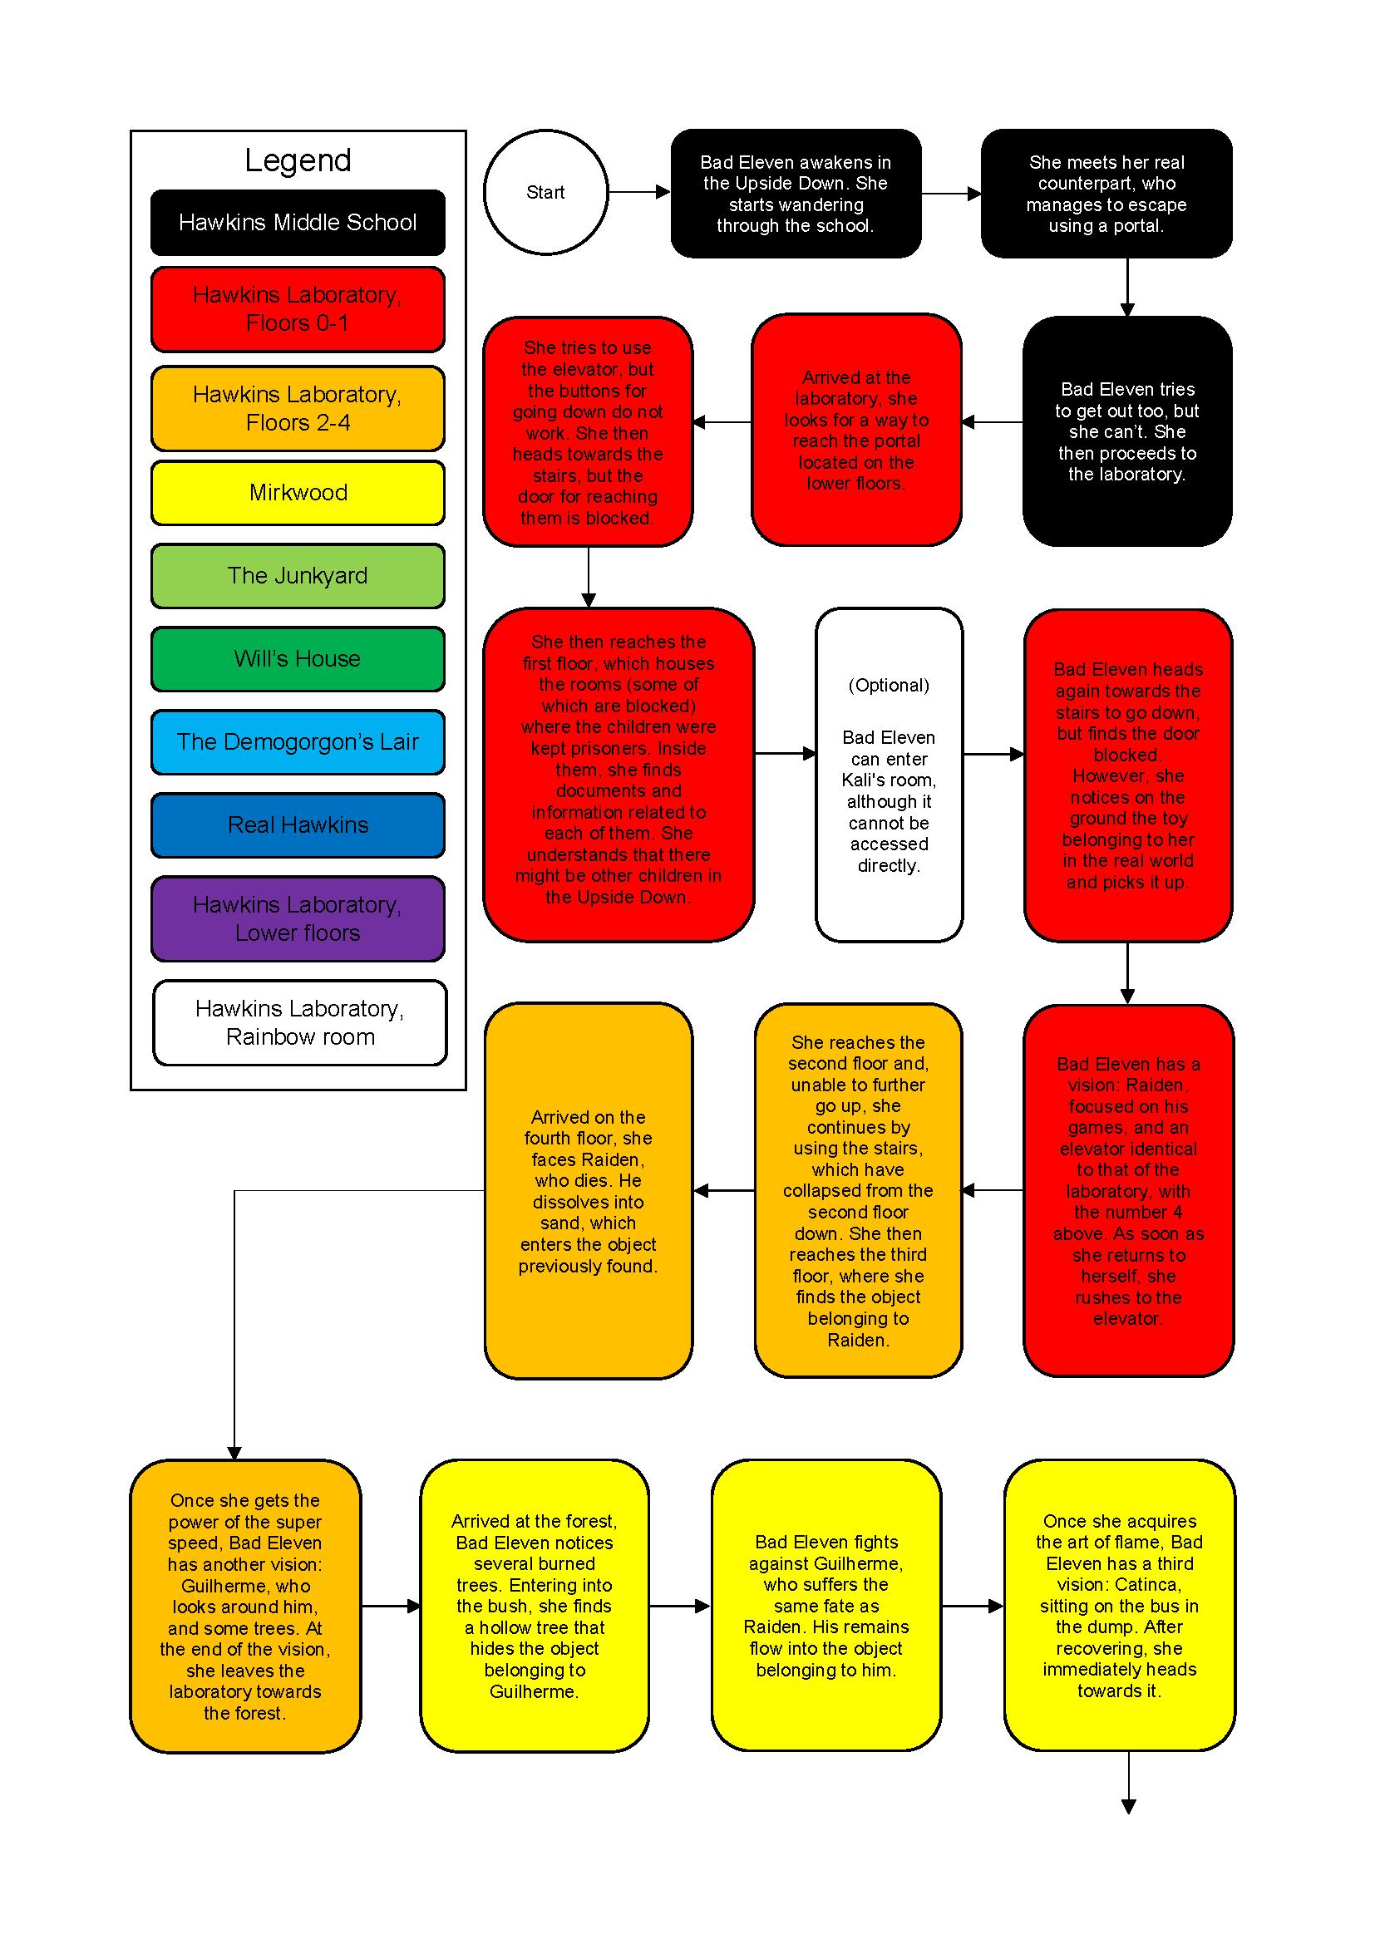

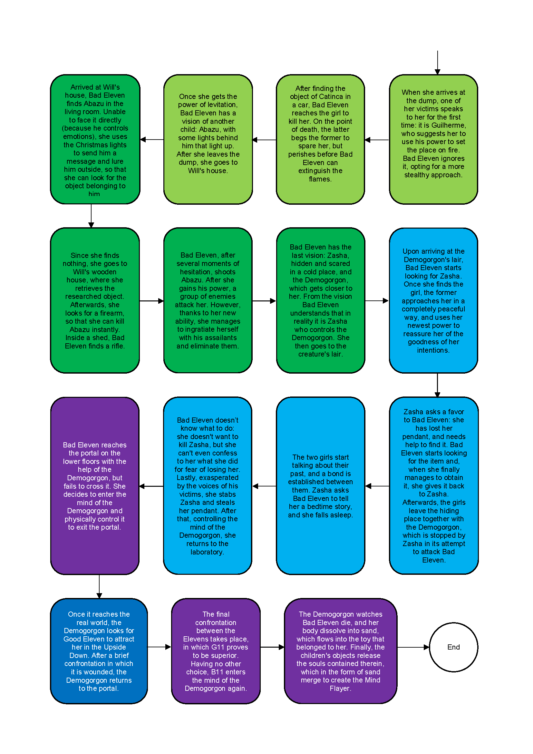

# 5. Themes

Betrayal  
The act of betrayal concerns the violation of someone’s trust or confidence or of something considered as a moral standard. This definition can be translated in the game using the relation that Bad Eleven maintains with Zasha. At the beginning, it seems that the two girls are friends, each one caring a trusting each other, but in the end Bad Eleven will reveal her true intentions, backstabbing Zasha just to accomplish her true will.

Stolen Childhood

All the children, sooner or later, experienced the tragedy of being kidnapped and separated from their family in order to be studied in the Dr. Brenner’s laboratories. Such theme is ever-present in the game thanks to the flashbacks that Bad Eleven will experience after having absorbed one child’s power.

Guilt

Although betrayal is contemplated, guilt is also an integral part of Bad Eleven’s mind and personality who, as the game progresses, will be consumed by it. In any case, she won’t be able to support such a deep condition, leading to the continuation of her murders.

Doubt

Doubt can be described as not being certain about or convinced of something. As the story develops, Bad Eleven will face the struggle of the other guys’ memories coexistence in her mind, creating the internal doubt of whether her actions are good or not. As the game progresses, these flashbacks will become stronger and stronger, almost paralyzing Bad Eleven.

Power

Searching for more powers and abilities in order to pass the gate leading to the real world is Bad Eleven’s ultimate desire. With this in mind she will wander the Upside Down, searching for other children of the Laboratory experiments, in order to absorb their powers and thus going back to the real world, replacing the authentic and ever-stronger Good Eleven.

# 6. Characters

## Bad Eleven

### 

### 6.1.1. Description

As the real Eleven killed the Demogorgon, a wave of energy created a bad copy of her in the Upside Down. She shares Good Eleven’s memories and powers, but she is much weaker and, being a copy, she can’t pass the gate to enter the real world. Her main goal is going back there and taking the place of Good Eleven, because she knows what the real world looks like and she doesn’t want to live in the Upside Down. After having met and killed the other children, this feeling grows stronger, because she doesn’t want to become like them. However, as she hears their stories and shares their memories, she starts to feel guilty and sad for them and for what they had to suffer. She will eventually be killed by Good Eleven and after becoming the Mind Flayer her main goal will be to destroy everything and to control the whole real world, in order to never have to suffer again.

Her object is a puppet, as shown in the first season of the series.

### 6.1.2. Circumplex

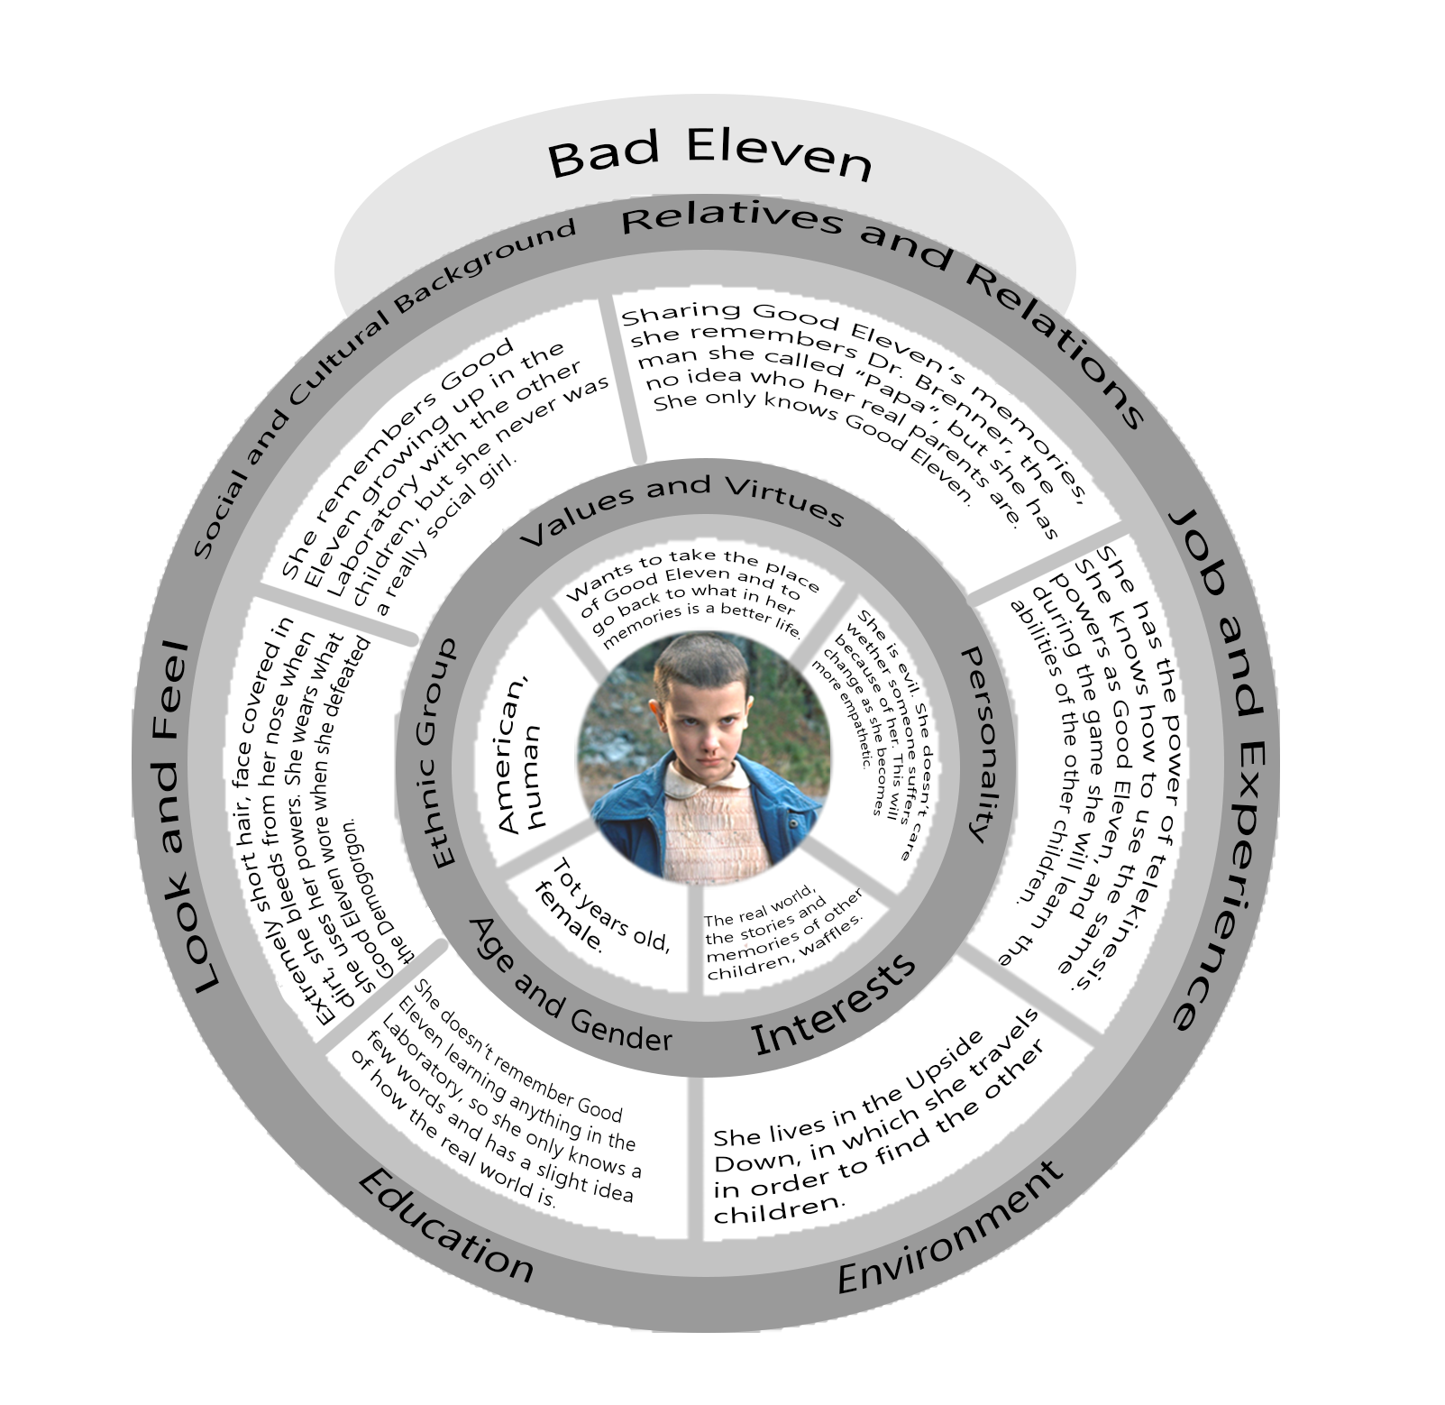

### 6.1.3 Map of the relations with the other characters

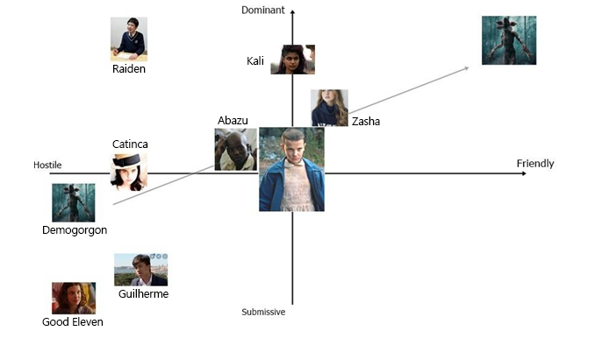

6.2. Good Eleven

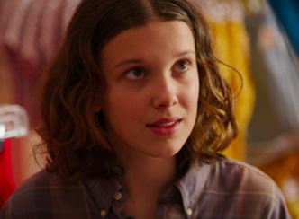

6.2.1. Description

She is a young girl, who has lived all her life in the Hawkins Laboratory as an experiment. It was her who opened the gate to the Upside Down in the underground floors of the Laboratory. After this she ran away and was found by the protagonists, who taught her how to live in the real world, which she had never seen before. She is shy, needs to learn how to speak, but she is kind and loving, and she doesn’t want the ones she loves to get hurt. Her powers are much stronger when she gets angry.

6.2.2. Circumplex

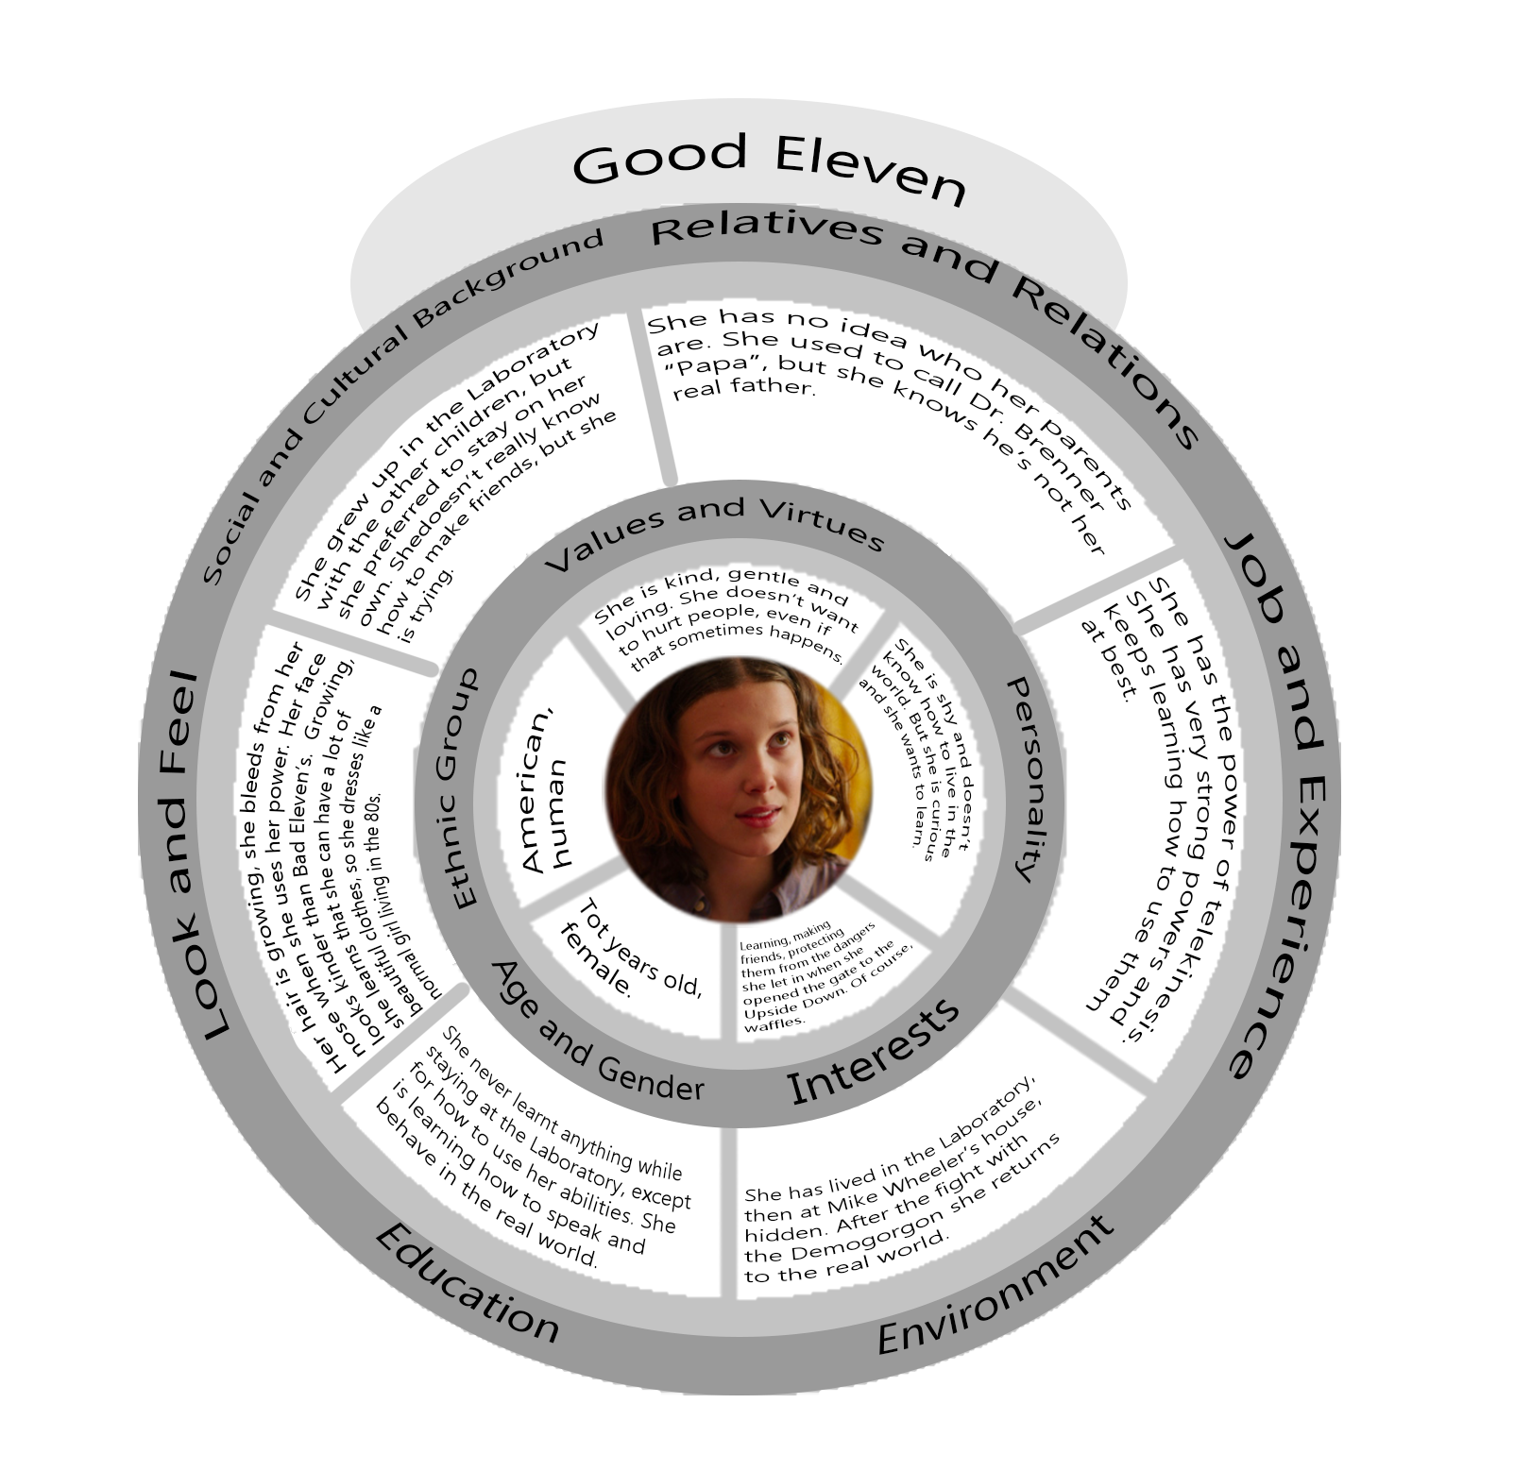

6.2.3. Map of the relations with the other characters

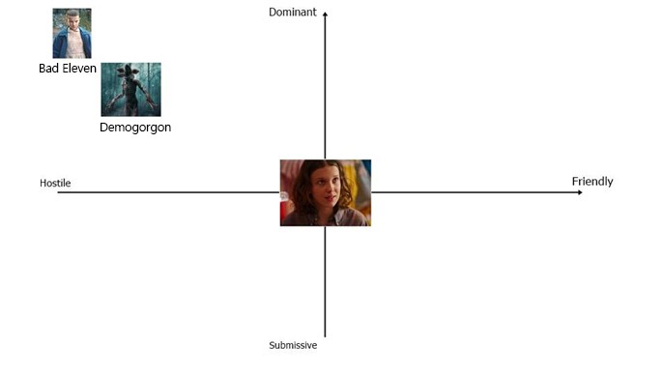

## 

## 6.3. Demogorgon

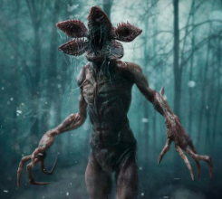

6.3.1. Description

It is the main antagonist of the first season of the series. It lives in the Upside Down, and he is first seen in a vision Eleven has while in the Laboratory. As she touches it, the gate between the two worlds opens and it immediately crosses it to come to the real world. It is a human-like predator, attracted by the smell of blood that prefers to hunt at night. It is really tall and has long arms, with deadly claws. It is hostile towards all the children except Zasha, who can control its mind and lives in its Lair.

6.3.2. Circumplex

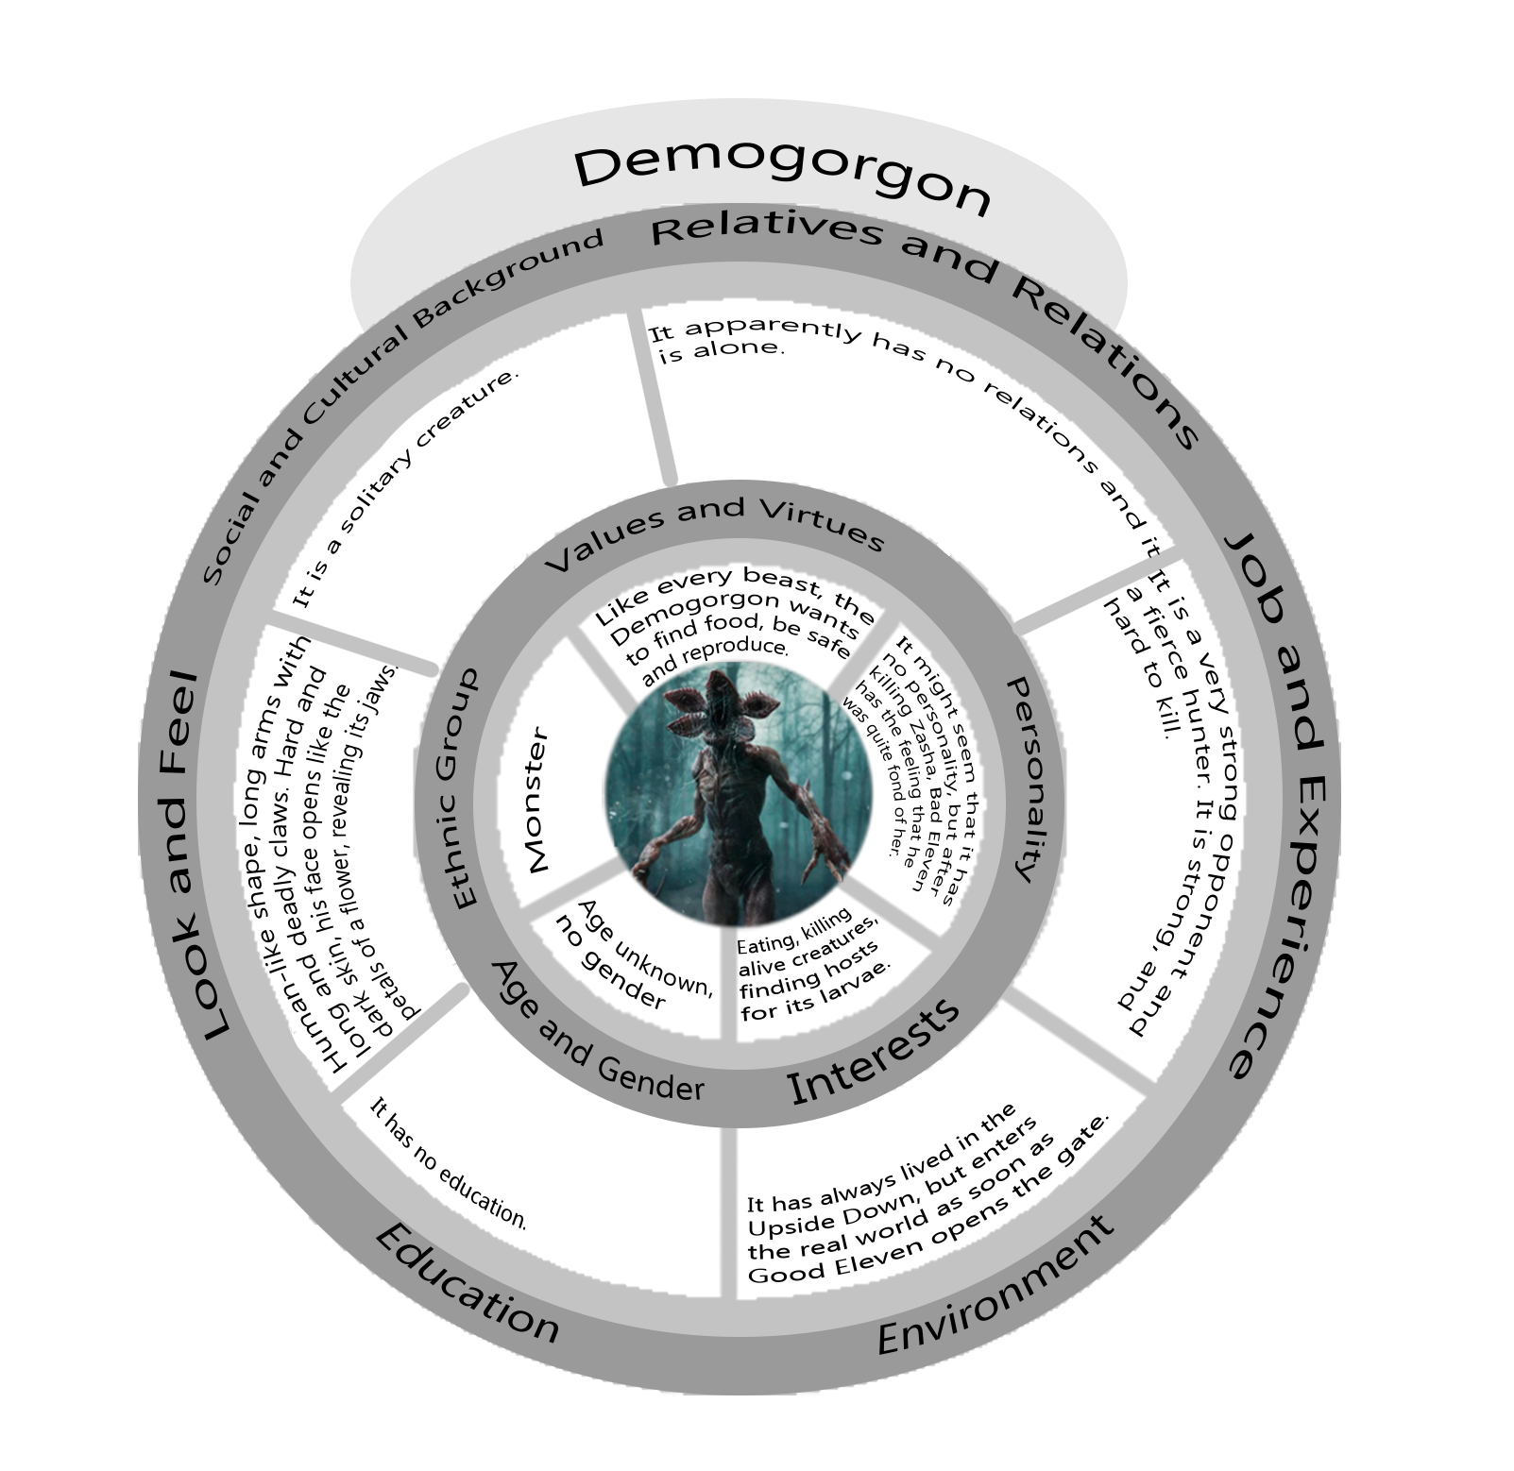

6.3.3. Map of the relations with the other characters

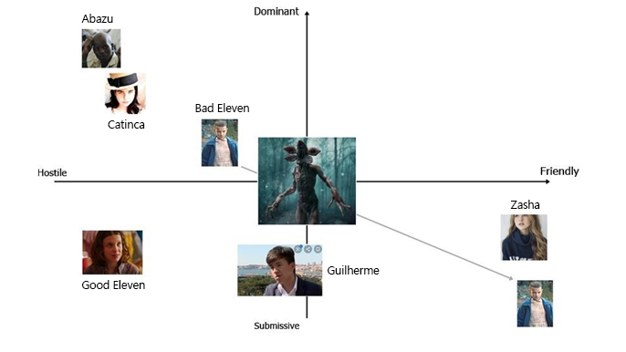

## 6.4. Kali Prasad (8)

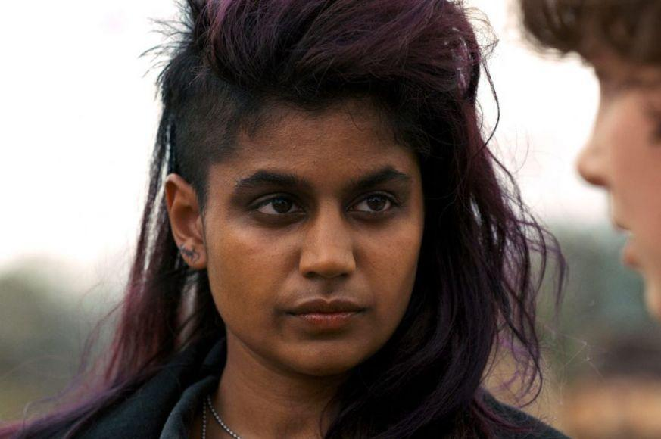

### 6.4.1. Description

Kali is a young girl born in London, who lived in the Hawkins Laboratory with the other children. She is shown in the second season of the series. She has the ability of giving people illusions, making them see what she wants. She is angry at the people who hurt her and the other children, and spends her time hunting them down and killing them. The bad copy of Kali generated while she was still in the Laboratory and had to create a gigantic illusion. Her power is of no use to the player, but if she is unlocked (by opening the Rainbow Room) she will help the player see the memories of the other children instead of just hearing them in her head.

Her object is a drawing of her and Good Eleven together, that is hanging on the door of the Rainbow Room.

6.4.2. Circumplex

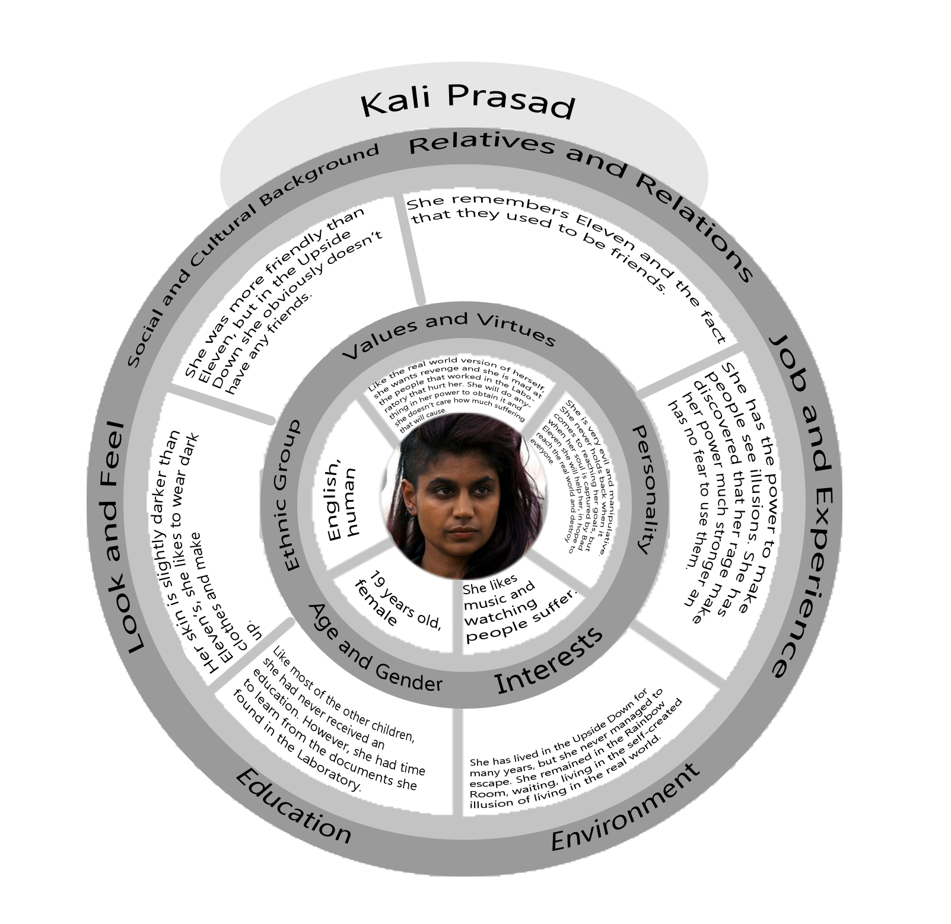

6.4.3. Map of the relations with other characters

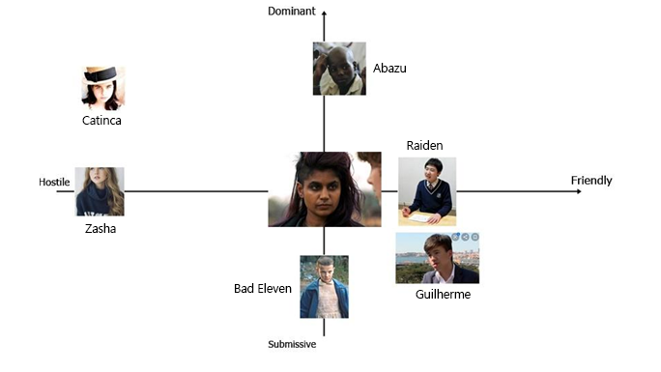

## 6.5. Raiden (1)

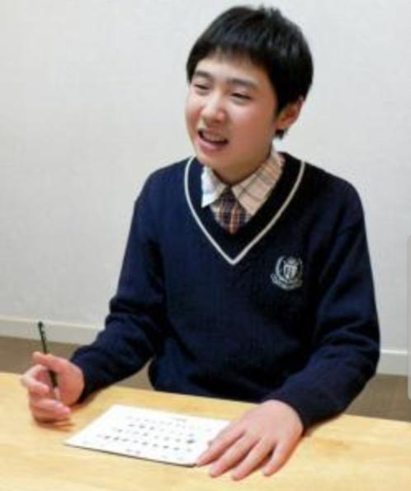

### 6.5.1. Description

### He is the son of a woman who lived near Nagasaki when she was a young girl. As soon as he was born it was clear that he had super powers. He was taken away by the men of Dr. Brenner at a young age and never saw his family again. He has always been a very clever boy and he liked to study so much that Dr. Brenner gave him books as rewards when the experiments went well. He can run and move at incredible speeds. His bad copy generated after an experiment in which he had to crash against an iron surface and has lived in the Laboratory ever since. He has collected all the books he could find and he keeps them with him to read them over and over again. He is not interested in going back to the real world.

His object is the first coloring book that was given to him when he was little.

### 6.5.2. Circumplex

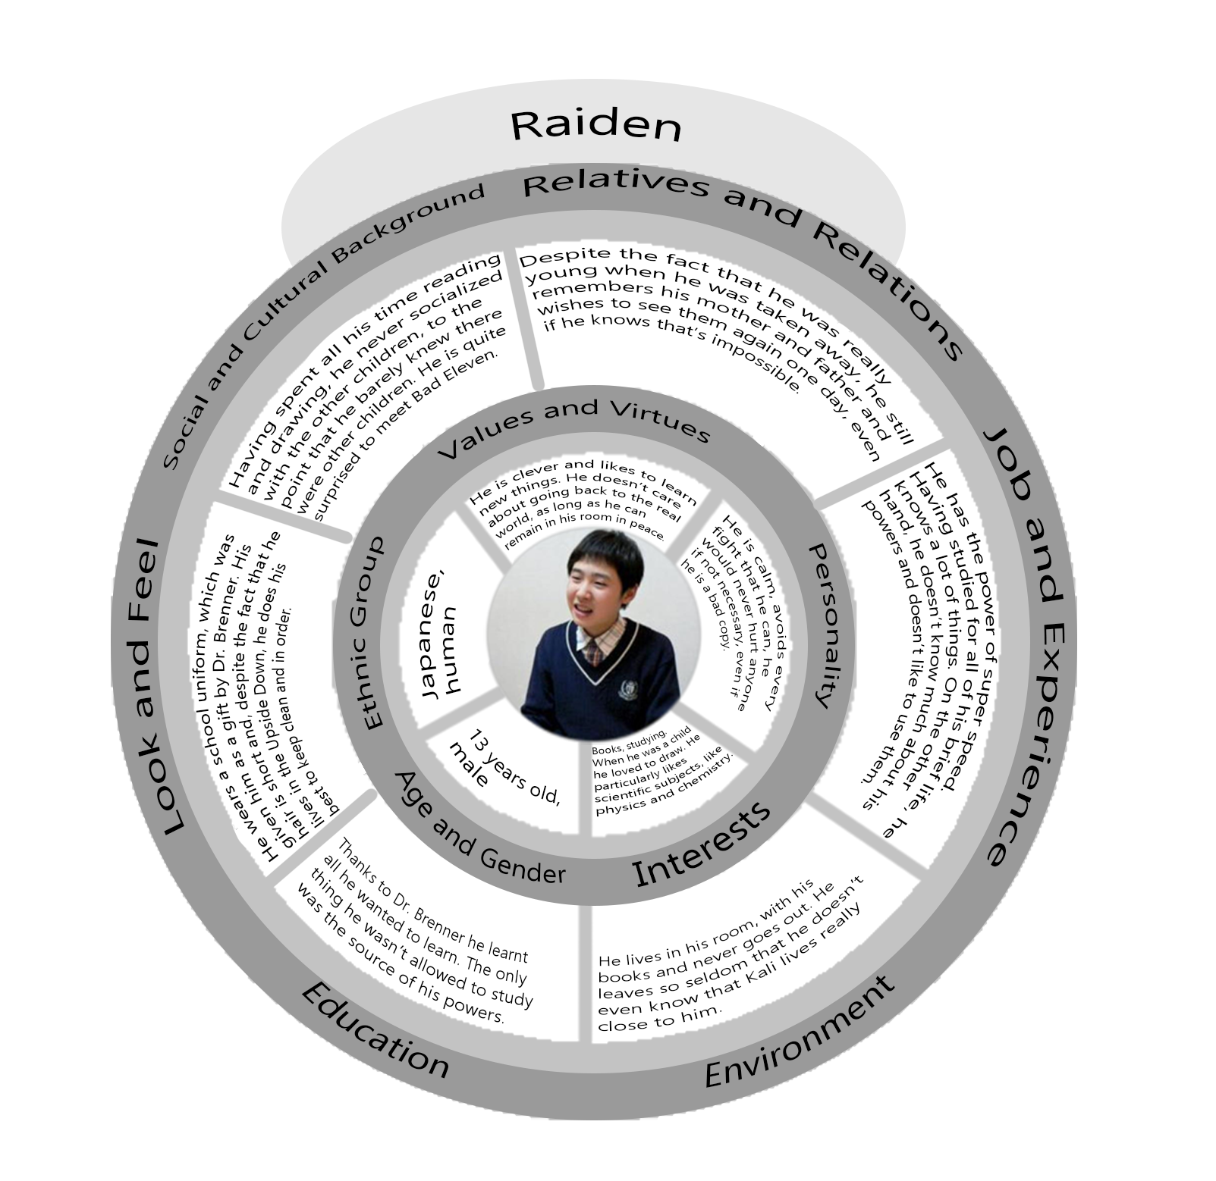

### 6.5.3. Map of the relations with other characters

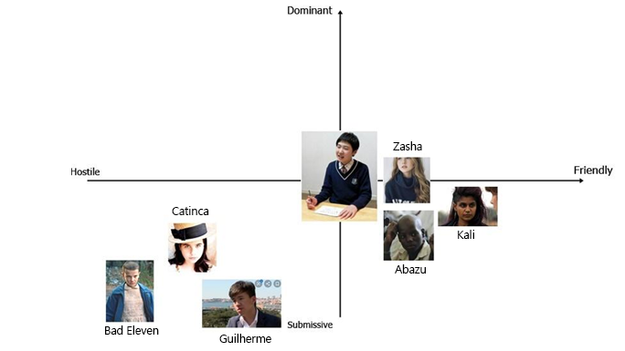

## 6.6. Guilherme (9)

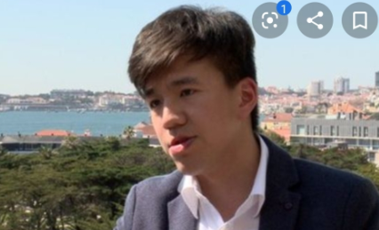

### 6.6.1. Description

Guilherme was born in Lisbon in 1972. His father was an abusive man aligned with the dictatorship and allowed his wife to be experimented on by the government. When Guilherme was born, he was taken away from her as another test subject and was only allowed to see his father. When the man find out that his son could control and generate fire, he had him isolated from the world in a special facility. He was found by Dr. Brenner and taken to Hawkins after the fall of the regime but he has been a difficult child to deal with ever since. The bad copy was generated when he tried to burn down the whole Hawkins Laboratory. In the Upside Down he likes to live in the woods and to explore. He is the only child who is not afraid to challenge the Demogorgon.

His object is a gun, which he found in the Laboratory and which he keeps as a reminder of what he believes his greatest success: his escape from the Laboratory.

6.6.2. Circumplex

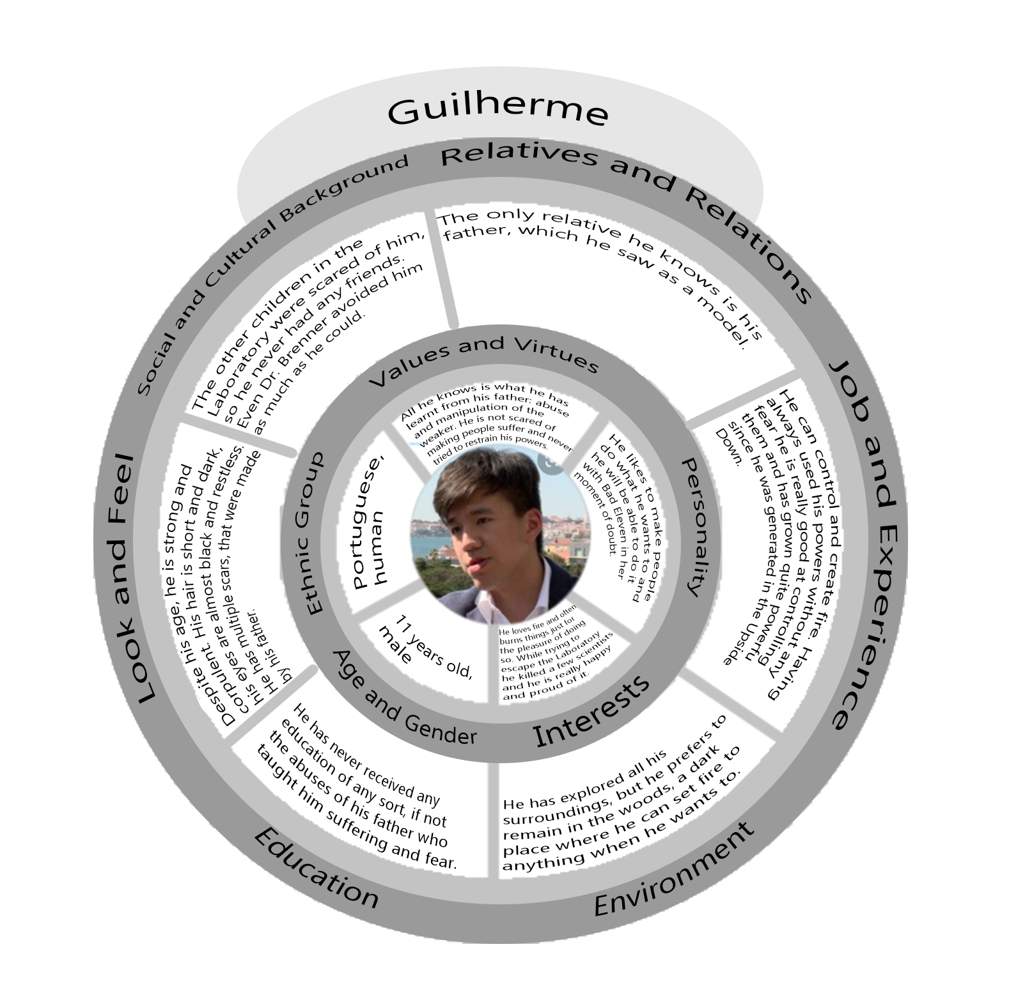

### 6.6.3. Map of the relations with other characters

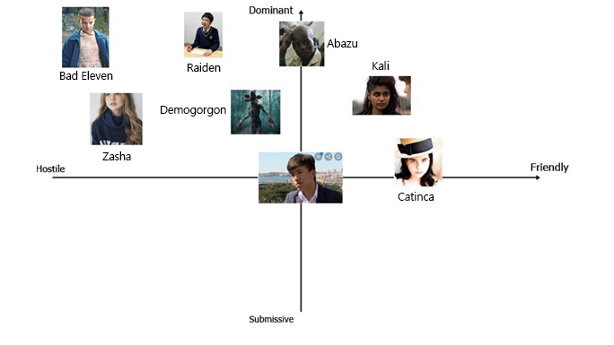

## 6.7. Catinca (3)

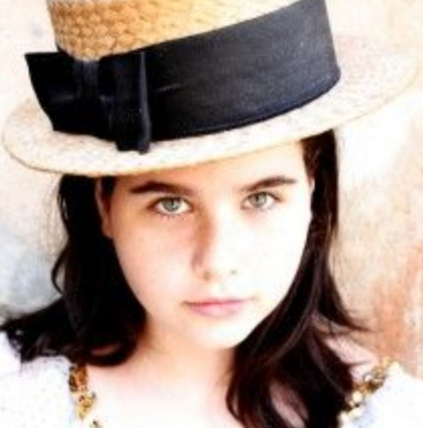

### 6.7.1. Description

Catinca was born in Transylvania in 1972 in a family of farmers. Her parents soon found out that she had the power of levitation and of duplicating herself, and forced her to use them in order to help them in their job. Due to this, she never got a proper childhood and she soon became famous in her small village. People began to pay her parents to have her help them in their farms too and so she spent her early days like a slave. As word spread out, Dr. Brenner found her and kidnapped her. In the Laboratory, she often refused to do what she was asked to do. Her copy was generated after a bad fight with the other children. When she arrived to the Upside Down she ran away and found a shelter in the junkyard, but was soon surrounded by Demodogs and other monsters. She has remained there ever since.

Her object is an apple.

6.7.2. Circumplex

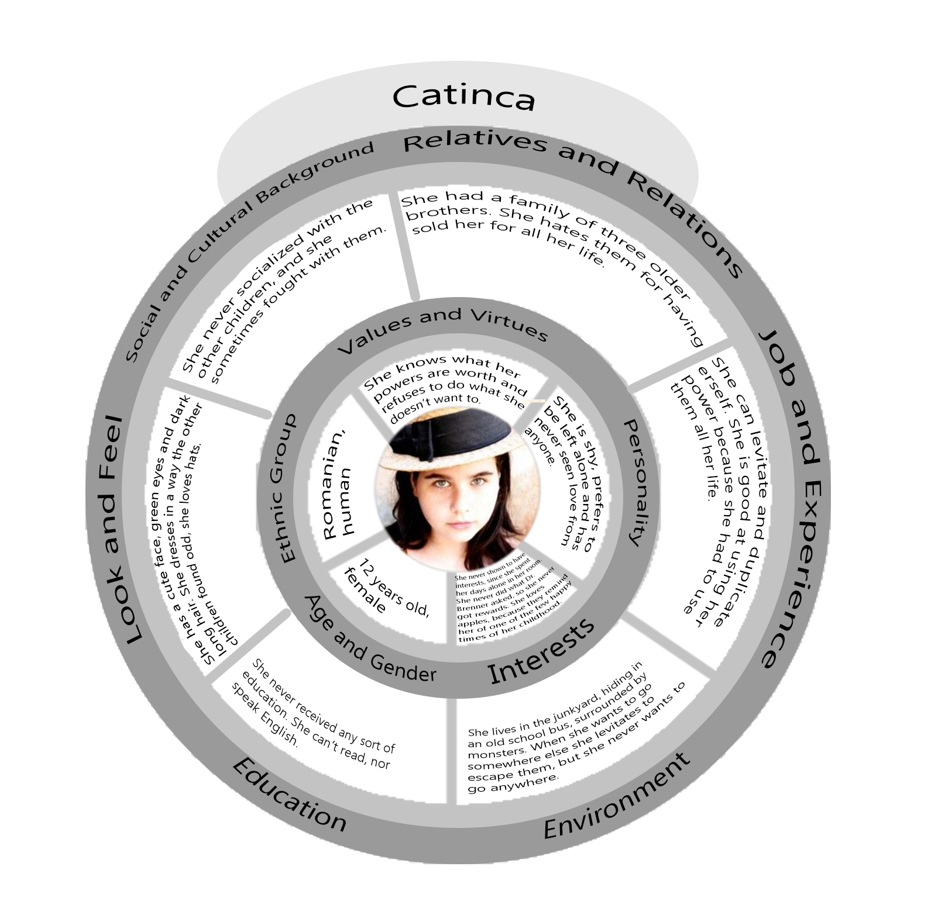

### 6.7.3. Map of the relations with other characters

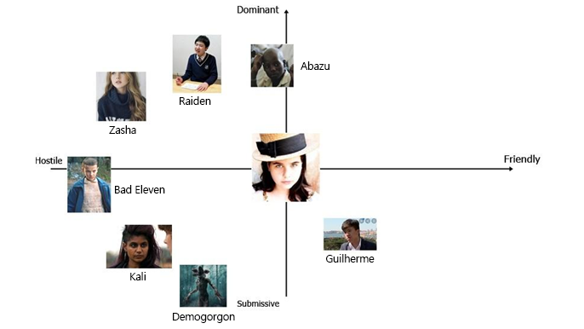

## 

## 6.8. Abazu (7)

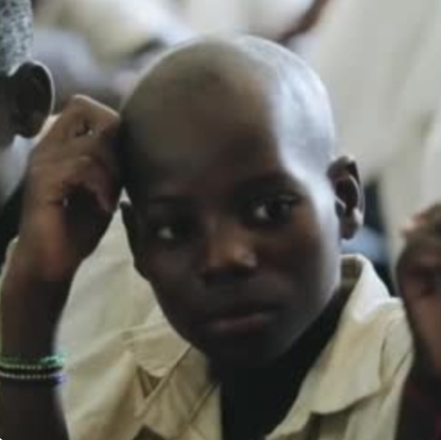

### 6.8.1. Description

He was born in Zimbabwe in 1968. He was born in a small village in a poor family, but has lived happily for a few years before being found by Dr. Brenner. He offered money to his family to buy him and it was him who convinced them to do it, in order to help them. He missed them and wished to go back to them one day, but he knew he couldn’t escape the facility in which he was kept. Due to his powers, everyone liked him and he has easily become the favourite children of the scientists. He was still in the Laboratory when Good Eleven opened the gate and his bad copy was generated by his attempt of befriending the Demogorgon in order to save everyone else. While his bad copy lives on, the real Abazu died in the attempt. The copy is hidden in Will’s house, because he spied on Will while he was in the Upside Down but didn’t dare to face the Demogorgon again, when it came to take the boy.

His object is a pirate ship in a bottle, given him by Dr. Brenner.

6.8.2. Circumplex

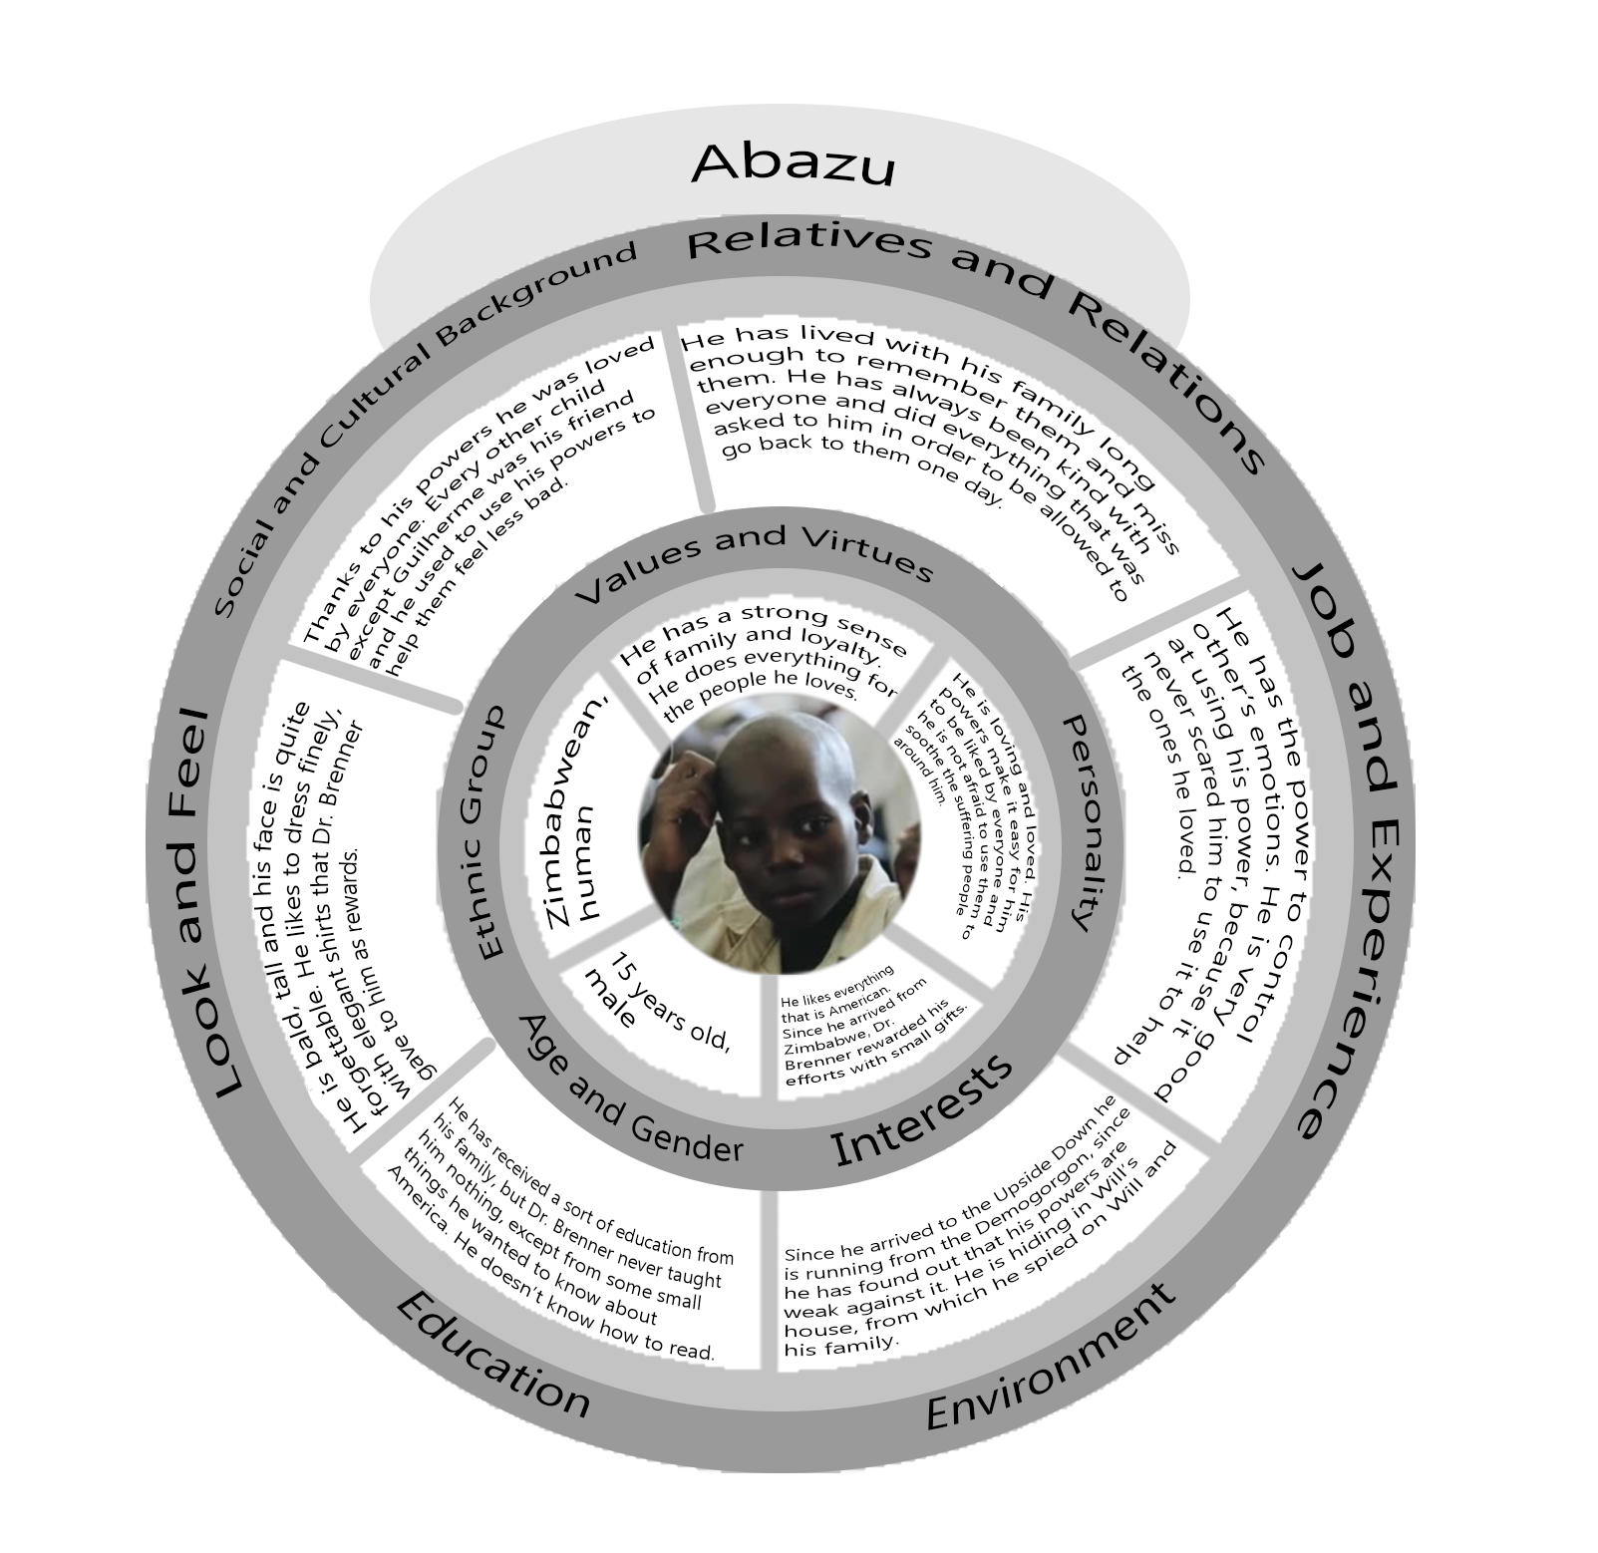

### 6.8.3. Map of the relations with other characters

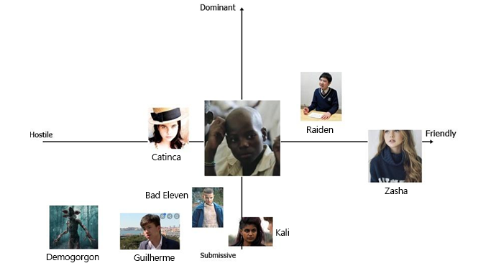

## 6.9. Zasha (5)



### 6.9.1. Description

Zasha was born in Russia in 1974. Her parents abandoned her in an orphanage when she was just a few days old. The nurses immediately understood there was something wrong with her and called the Russian intelligence. She became an experiment when she was two years old, but it took months before the scientist could figure out that she could control their minds. She underwent brainwash and was sent to America, in a way that Dr. Brenner could find her so she could control him. Something didn’t work out and she was imprisoned in Hawkins Laboratory, far from all the other children. She was tortured with electricity and was constantly drugged. The copy in the Upside Down was generated while she was trying to escape, failing. She doesn’t like the Upside Down, but she feels safe in the Demogorgon’s Lair, where she can control him to make him protect her.

Her object is a pendant with the pictures of her parents, the only thing from her childhood that she has been left with. She has lost it in the depths of the Lair and is scared to go back to look for it.

### 6.9.2. Circumplex

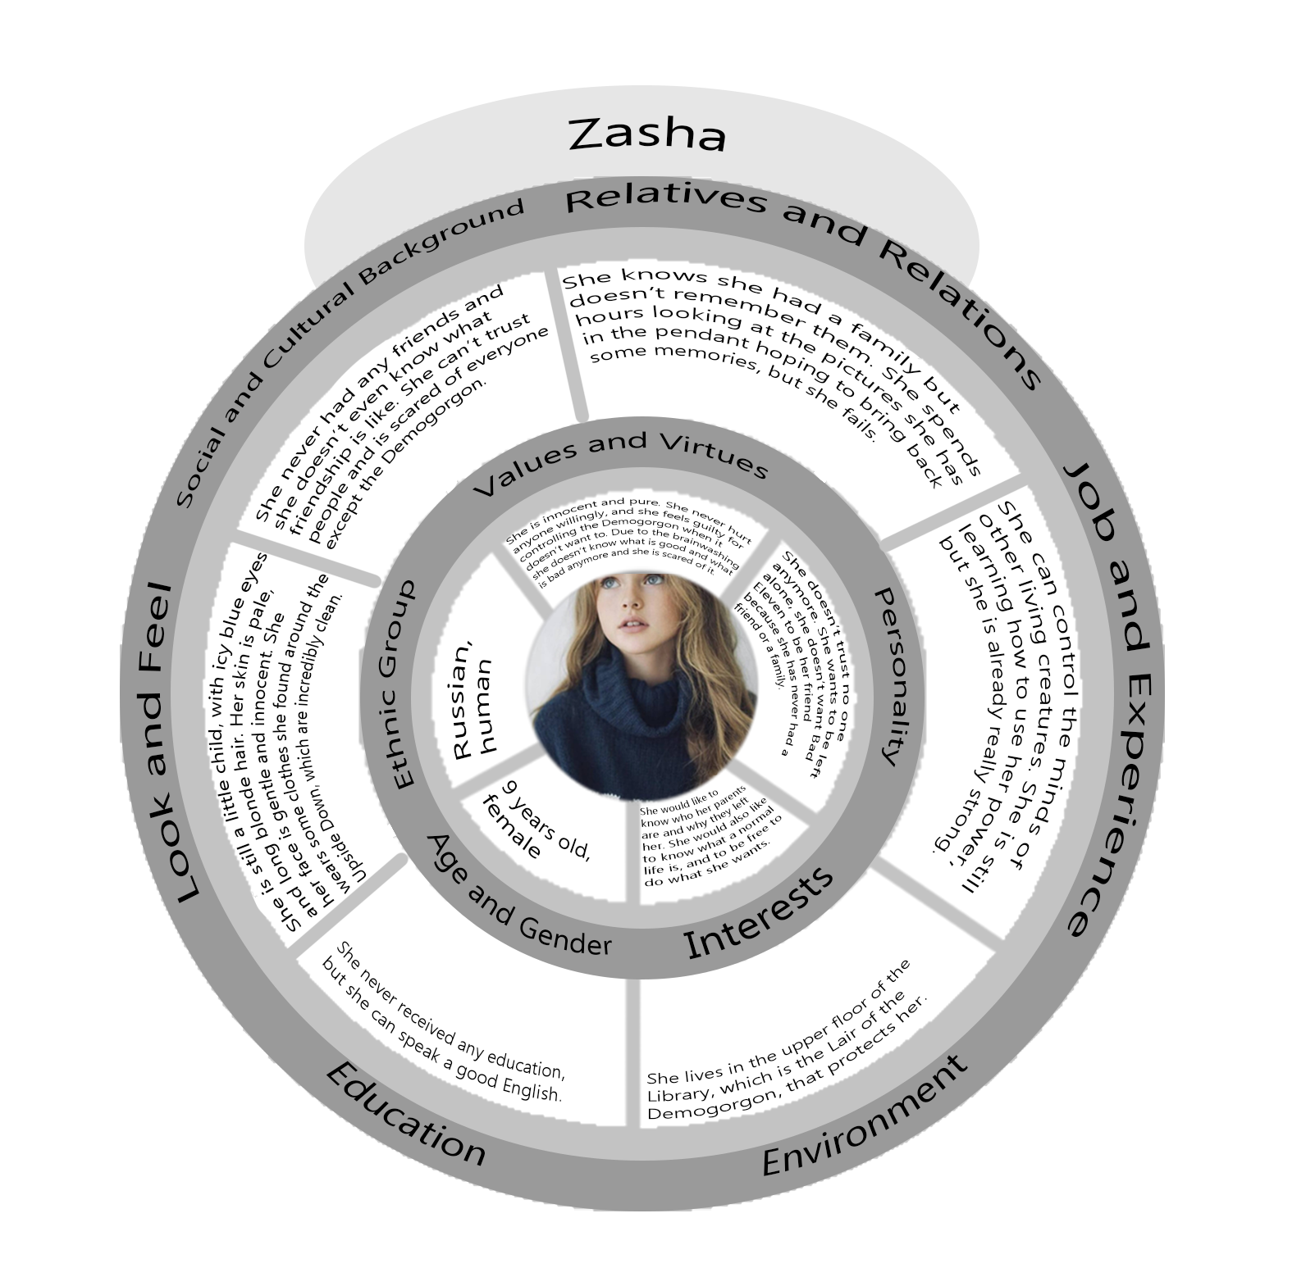

### 6.9.3. Map of the relations with other characters

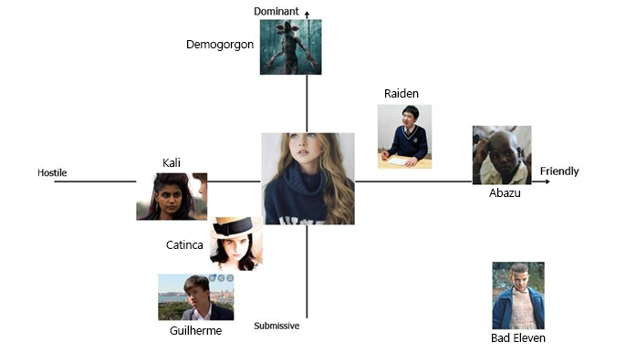

7. World Diagram

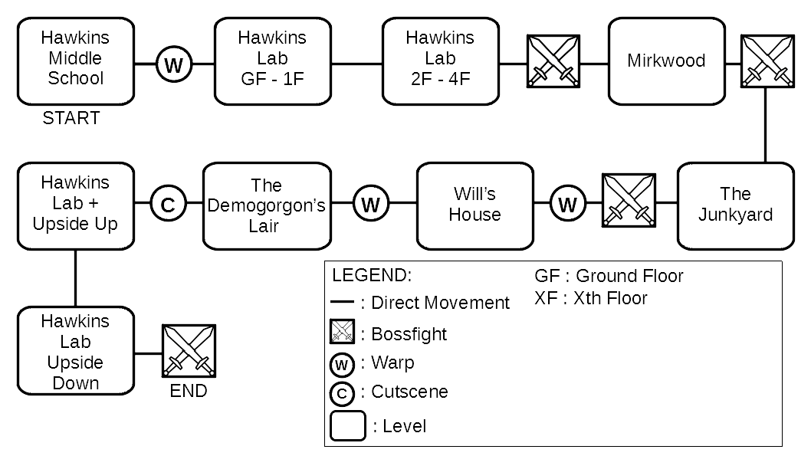

8. Goal Outline

# 8.1. Hawkins middle school

* Explore the school (Tutorial movement & Telekinesis & Items)
* Find the exit

# 8.2. Hawkins Laboratory, Upper floors

* Open the laboratory doors (puzzle)
* Floor 0
  + Explore the floor
  + Find the Elevator
  + Access the Elevator (puzzle)
  + Find the stairs
  + Go back to the Elevator
* Floor 1
  + Explore the floor
  + Visit the children rooms in order to get information about them
  + Find the stairs
  + Pick up Eleven’s Toy
  + Go back to the Elevator
* Floor 2
  + Explore the floor
  + Find the stairs
  + Open the door to access the stairs (puzzle)
* Floor 3
  + Explore the floor
  + Find the Raiden’s toy in the office (puzzle)
  + Go back to the stairs
* Floor 4
  + Defeat Raiden (Miniboss)
  + Tutorial super-speed
* Exit the laboratory

8.3. Mirkwood

* Enter the woods
* Explore the area (puzzles)
* Find Guilherme’s toy in a hollow tree
* Find Guilherme
* Defeat Guilherme (using super speed)

# 8.4. The Junkyard

* Explore the area in a stealthy way.
* Find Catinca’s toy in a abandoned car
* Open the car (puzzles)
* Find Catinca (she is hiding on the bus)
* Defeat Catinca (using telekinesis & fireballs)

# 8.5. Will’s House and Castle Byers

* Frontyard
* Explore the area
* Spot Abazu in the living room
* Lure Abazu outside the house in order to find his toy first (light puzzle). It will probably be necessary to do this multiple times, as Abazu comes back after a while.
* Enter the house
* In the house
  + Search for Abazu’s toy
* Move to Castle Byers
* Castle Byers
  + Open Castle Byers door and enter in it (puzzle)
* Pick up Abazu’s toy
* Reach the garage
* Garage
* Open the door (puzzle)
* Pick up the Rifle
* Go back to the house where Abazu is
* Shoot Abazu
* Defeat the demo-creatures (emotional control tutorial)

# 8.6. The Demogorgon’s Lair

* Explore the area
* Find Zasha (puzzle)
* Use the emotional control power to manipulate and approach her
* Find Zasha’s pendant in the lower floors of the Lair
* Befriend Zasha
* Kill Zasha
* Escape the Demogorgon
* Reach the gate in the Laboratory (using the Demogorgon)
* Pass the gate (failed)
* Pass the gate (using the Demogorgon)

# 8.7. Real Hawkins

Using the Demogorgon:

* Explore the area (puzzles)
* Find G11
* Fight and kill G11
* Escape and lure G11 in the Upside Down

# 8.8. Hawkins Laboratory, Lower floors

* BOSS FIGHT against G11
* Use the Demogorgon to defeat G11 once and for all
* END

9. Look & Feel

Horror like Outlast but a little bit less splatter and more “nostalgic?”

Outlast 1 and 2

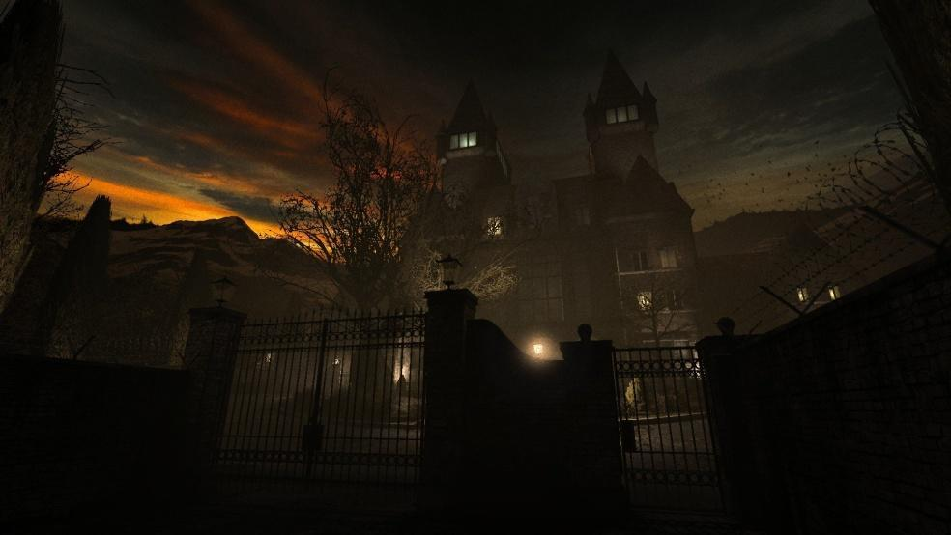

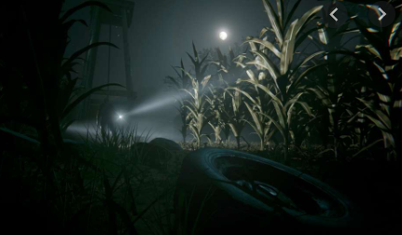

Stranger Things (Upside Down)

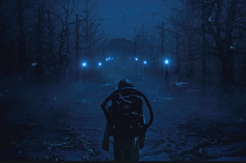

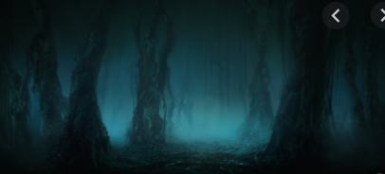

Penumbra Necrologue

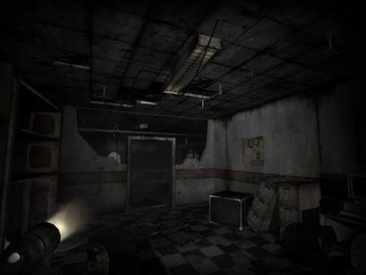

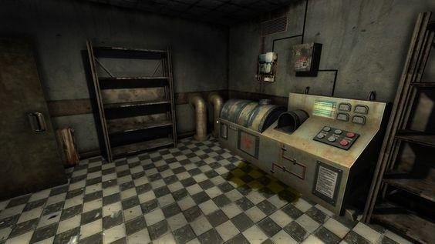

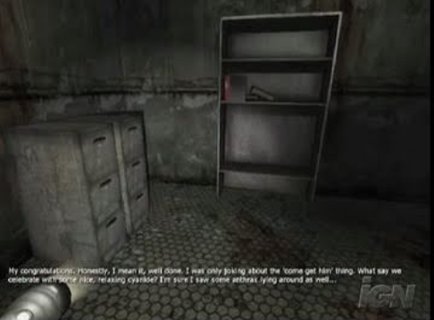

Eleusis

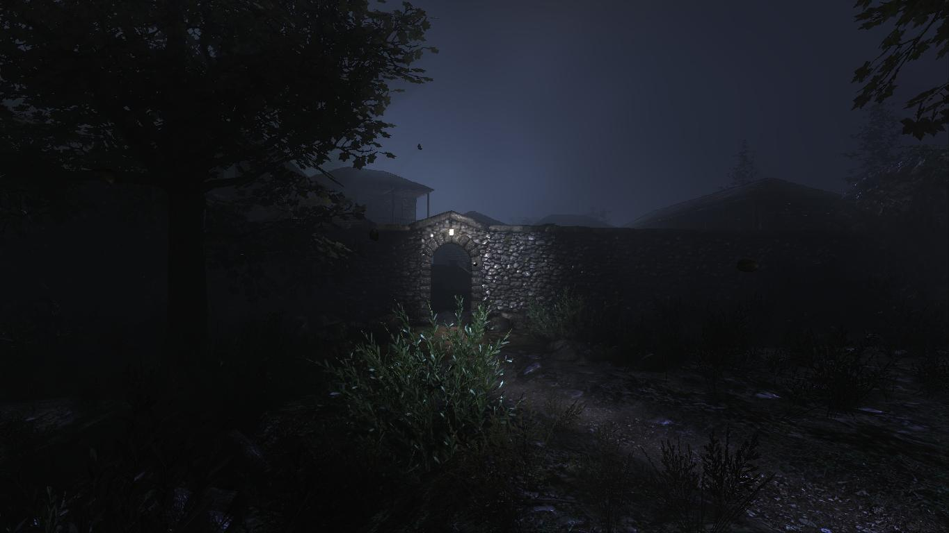

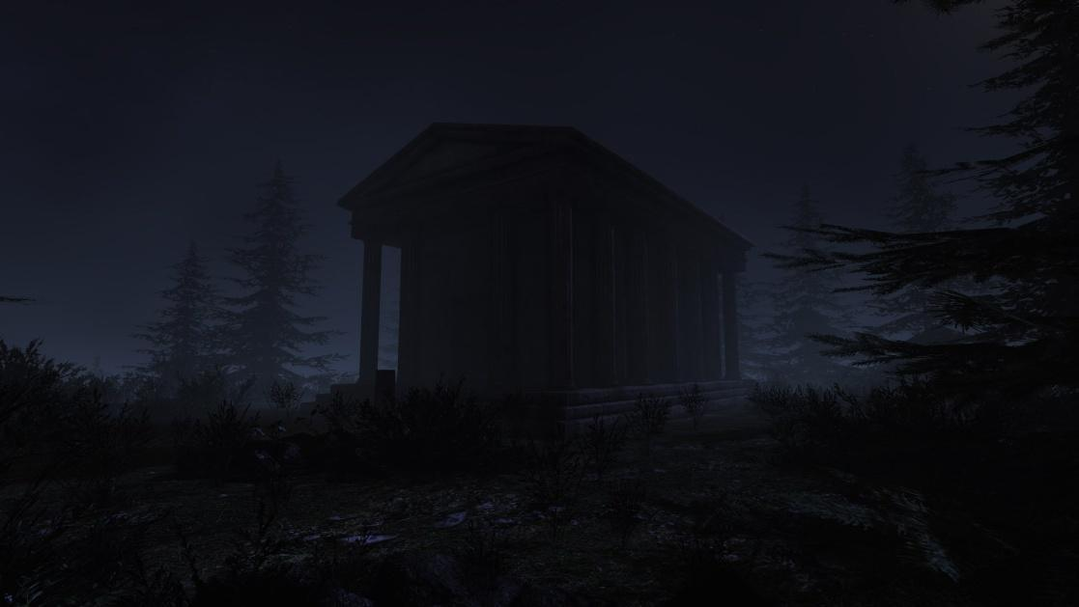

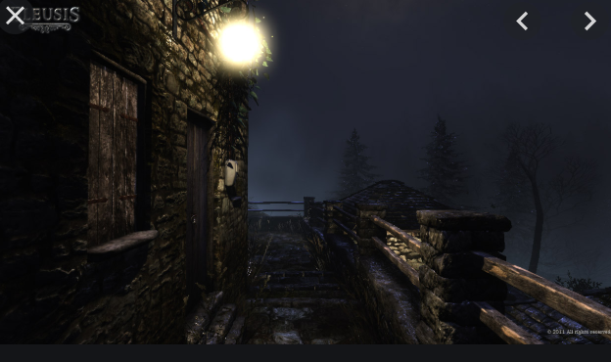

Unforgiving, a northern hymn

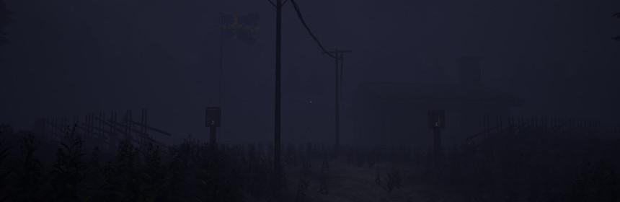

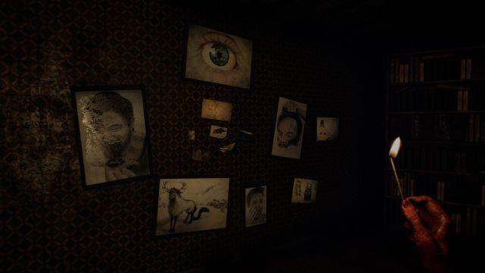

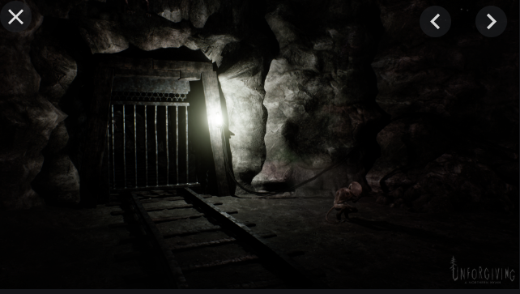

10. Level Story

B11 arrives at the Library, the place where the Demogorgon lives. As she enters, she finds herself into the hall. The place is dark and all covered in black vines. In front of the entrance there is a desk with some lamps spreading a feeble light nearby. On her left the space is filled with shelves of books. When she looks closely she realizes that she can open and read some of them (easter eggs, foreshadowings and tributes to the other children):

- *The Little Prince* by Antoine de Saint-Exupéry:

«“I am looking for friends. What does that mean -- tame?"

"It is an act too often neglected," said the fox. "It means to establish ties."

"To establish ties?"

"Just that," said the fox. "To me, you are still nothing more than a little boy who is just like a hundred thousand other little boys. And I have no need of you. And you, on your part, have no need of me. To you I am nothing more than a fox like a hundred thousand other foxes. But if you tame me, then we shall need each other. To me, you will be unique in all the world. To you, I shall be unique in all the world.”

“People have forgotten this truth," the fox said. "But you mustn’t forget it. You become responsible forever for what you’ve tamed. You’re responsible for your rose.”»

- *To the lighthouse* by Virginia Wolf:

« “At home the mountains are so beautiful,” and there was no hope, no hope whatever»

- *Indigenous races of the earth* by Josiah C. Nott:

# 

- An Orienteering Manual

- *Treasure Island* by Robert Louis Stevenson:

«We must go on, because we can’t turn back»

- *The Overcoat*, by Nikolai Gogol:

«And Petersburg was left without Akakii Akakievich, as though he had never lived there. A being disappeared, and was hidden, who was protected by none, dear to none, interesting to none, who never even attracted to himself the attention of an observer of nature, who omits no opportunity of thrusting a pin through a common fly, and examining it under the microscope. »

- *Dracula* by Bram Stoker:

«Do you not think that there are things which you cannot understand, and yet which are; that some people see things that others cannot? But there are things old and new which must not be contemplate by men´s eyes, because they know -or think they know- some things which other men have told them. Ah, it is the fault of our science that it wants to explain all; and if it explain not, then it says there is nothing to explain.»

- *Oroonoko* by Aphra Ben:

«And ’tis most evident and plain that simple Nature is the most harmless, inoffensive, and virtuous mistress. ’Tis she alone, if she were permitted, that better instructs the world than all the inventions of man. Religion would here but destroy that tranquillity they possess by ignorance; and laws would but teach ’em to know offense, of which now they have no notion.»

- Poetry by Fernando Pessoa:

«I am the escaped one,

After I was born

They locked me up inside me

But I left.

My soul seeks me,

Through hills and valley,

I hope my soul

Never finds me.»

- *Hagakure* by Yamamoto Tsunetomo:

«There is something to be learned from a rainstorm. When meeting with a sudden shower, you try not to get wet and run quickly along the road. But doing such things as passing under the eaves of houses, you still get wet. When you are resolved from the beginning, you will not be perplexed, though you will still get the same soaking. This understanding extends to everything.»

On the other side of the room the roof is collapsed and hides some tables. There is a door, covered in vines but B11 can’t open it. Behind the desk are the stairs to the upper floor. While she explores the other children start talking to her.

Abazu: “I don’t like it in here”

Guil: “You’ll get used to it, shut up”

Abazu: “So you plan on killing a little girl?”

Catinca: “Like she killed everyone else, if only I had seen her coming..”

On the second floor there is a room with the door covered with a knot of three vines, which covers the roots of a fourth one; the roots of these vines are scattered, respectively, in one of the three other rooms of the floor. B11 will have to find them and burn them in order to free the way. The floor of the room on the right is collapsed, so she will have to use the super speed to reach the roots and burn them. In the second room the roots are hidden behind some heavy objects, so she will use her power and lift them. In the last room the vines are above a high shelf of books, so she will levitate to reach them. Now the way to the other room is almost free, after having burned the last vine effortlessly she will be able to enter.

Cati: “Go on with the last step of this madness now”

Abazu: “You still have a choice, just go back and try to live your life like we all did”

Cati: “Yeah, and just wait for the next child to come and murder you like you did with us”

This room is again full of bookshelves. In a corner Zasha is sitting, terrified when she sees B11 approach.

Z: “How you find me? Who you? What you want from me?”

B11 uses Abazu’s power to calm Zasha before answering.

B11: “I am a friend. I don’t want to hurt you. I arrived at the Laboratory and found out that I wasn’t alone, I saw you. It is my power, to have visions, don’t be afraid. I came here looking for you, as a friend. I will help you now, will you let me?”

Z: “Why we here? I no like it here. Want go home.”

B11 (again using Abazu’s powers): “I can help you go home, but you need to trust me. I might know a way to get out, but I need to know more about you and your powers. What can you do?”

Z: “Mind. I control it. I control monster lives here. He no hurts me, he hurts who I want.”

B11: “That is good, we can escape. Is there anything you want to take with you?”

Z: “My book. And necklace, with mom photo on it. But I lose it underground and am afraid to go back and take it. Can you?”

Guil: “That must be her object, we need to find it before killing her”

B11: “Yes, tell me where to go”

Z: “There is a door down. You go down and down and down and find it. But monster is down too, I no control it, too far”

B11: “Don’t worry, I’ll be back”

B11 leaves Zasha alone and goes back. Now the door on the ground floor is free from the vines because Zasha removed them with her mind control. On the other side of the doors there is a staircase that leads to the lower floor, in which B11 finds the archives of the Library. She can explore but she will find nothing interesting. On the side opposite to the door there is a hole in the wall, probably dug by the Demogorgon. B11 enters it and finds herself in a labyrinth.

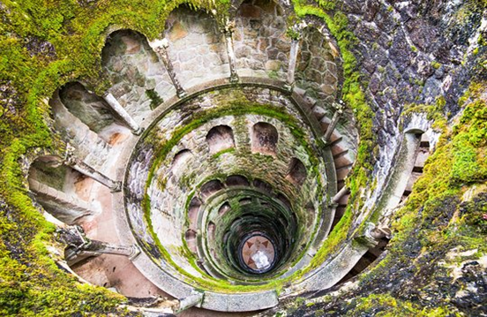

Here she will have to try to find the way to the other exit and at the same time she will have to run from the monster, which has found her. To help her, she will have small rooms in which she can hide without being seen by the Demogorgon.

At the center of the maze there is a staircase, similar to the one in the picture but carved by the Demogorgon. As Eleven descends it she sees the Demogorgon following her on the other side. Towards the end a part of it is missing and she falls into a gigantic cave, the lair of the monster.



The first room is the biggest, but it is also flooded. Eleven has to be careful not to make too much sound. As she proceeds, she hears the Demogorgon around her, but they can’t see each other.

Guil: “We are close, we can do it”

B11: “I don’t want to do it”

Guil: “What?”

B11: “I don’t want her to die. She is too little”

Abazu: “You don’t have to do it, you could help her”

Cati: “She must do it. She’s come too far to stop now”

Abazu: “But what if we all tried to get out without killing someone else? As a family”

Cati: “I don’t need a family”

Guil: “I want to kill my family too, now shut up before the Demogorgon finds us or I swear I’ll find a way to leave you with it for the rest of your days”

In the second room some Demodogs are sleeping peacefully. It is here that they grow and rest, while the Demogorgon takes care of them and feeds them. Eleven will have to be extremely quiet If she wants to get out alive.

B11: “A little girl like she is..all alone..down here..”

Guil: “She will soon be dead and no longer alone”

Raiden: “I wonder how these monsters see or feel the world around them. Maybe we could find a way to defeat them”

Cati: “Or maybe we could use the power of the little girl to make them do what we want. Take back our lives in the real world”

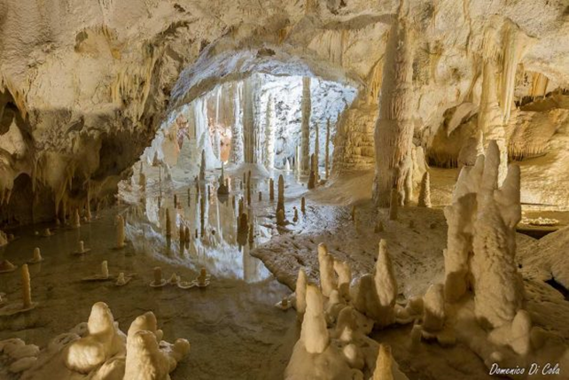

As she enters the last room, Eleven notices the pendant on a pinnacle. The whole cave seems very unstable and silent, except for the sound of drops of water falling. As she approaches the other children start talking to her.

Raiden: “Be careful, don’t make a sound. Even a whisper could make it all fall”

Guil: “Oh yeah, and how do you know?”

Raiden: “I liked to read remember? Papa always gave me books”

Cati: “Spare us the part where you tell us how much Papa loved you, you poor thing. You ended up here like the rest of us”

Abazu: “Maybe we should stop it and concentrate on what we need to do?”

Cati: “Says the one sold like a slave. Family really loved you uh?”

Abazu: “How do you know?”

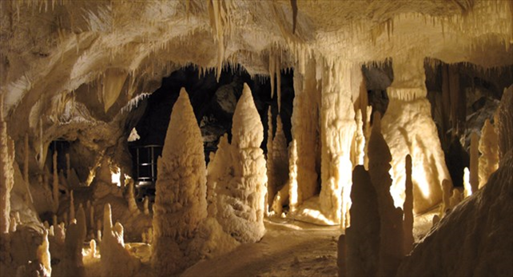

Cati: “I remember Papa talking about someone they *bought*. With actual money. He used to joke about it a lot with the other scientists”

Abazu: “They didn’t sell me. I sold myself. For them. I don’t believe you, Papa was a good man, he wouldn’t..”

Guil: “Was he? Why don’t you tell him about all the times he put you into confinement cells Eleven?”

B11: “Please just shut up”

Eleven manages to take hold of the necklace, but the other children won’t let her alone.

Guil: “Maybe some memories will help you remember why you want to kill that little girl and go back to the real world”

B11: “Papa is dead”

Cati: “But the others aren’t”

B11: “Stop it”

Guil: “They beat me and kept me in chains”

Cati: “They locked me in my room for days, just like you”

B11: “STOP!”

As she screams, she hears a rumble coming from the ceiling. The whole cave starts collapsing, the stalactites start falling all over the place.

Raiden: “There! A squeeze!”

Eleven rushes towards it and enters it. The tunnel is dark and narrow, but she manages to crawl until the end of it. She finds herself under a bookshelf in the archives under the Library, so she pushes it away and goes back to Zasha.

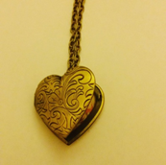

As she arrives in the room where Zasha is, she finds her sleeping on the floor, curled under a dirty blanket. She could wake her up and give her the necklace back, or just stab her and take her soul and powers. Without conferring with the other children, Eleven wakes Zasha up and hands her the necklace. The little girl opens it, stares at the picture hidden inside it and starts crying.

B11: “What? What happened?”

Zasha: “This my mother. Never see her, just this. But I know this my mother”

B11: “You have never seen her? Why?”

Zasha: “She leave me. Orphanage? In Russia, cold, alone, afraid”

B11: “And then? What happened? Why did you end up here?”

Zasha: “Doctors came. Said I dangerous. Took me away and studied. Then they hurt me, really bad and tell me things. America bad, America hurt me. And then took me to America, leave me like mother”

B11: “And Papa found you? He saved you?”

Zasha: “He no Papa, he no save. He put me in cage, use electricity on me. Hurt me like doctors in Russia. I always sleep, they fear me. On day I try to run and arrive here. I no like it here, but library is safe, monster keep me safe”

B11: “Don’t worry, I am here now. You’re safe with me. I won’t hurt you. Now try to sleep, before we escape from this place”

Zasha smiles and returns to the place where she was sleeping. She closes her eyes, her cheeks still wet. While she waits for Zasha to fall asleep Eleven is tortured by doubt. She really wants to go back to the real world, but she doesn’t want to kill an innocent child.

B11: “I won’t do it. I will tell her the truth, make her trust me, make her use her powers and get out”

Abazu: “She is way stronger than I was, I’m not sure you could make her trust you again, if you told her that you killed us”

Guil: “And you’d always have someone you must rely on. Someone who could just want to go back to Russia and look for her damned mother. You need to take her powers”

Cati: “Or just kill her for the sake of killing her. You killed us all, why should you stop now?”

B11: “She doesn’t deserve the pain”

Cati: “Oh did we? If only I was still alive I swear I would..”

Guil: “We help you come this far, kill her. And once you did you can go back to the real world and avenge us all. Destroy everything you want. You would be the most powerful being ever existed, no one could stop you. Us”

Abazu: “Or maybe you could make something up. The real Eleven is your twin, she sent you here, hurt you like they hurt her and you need help to kill her”

Guil: “She is way too powerful to let her live. She could stop us all. Do you want to be stopped? Again?”

With her hands shaking, Eleven draws the knife she stole from Will’s house. She is as close to Zasha as she can get, holding her breath in fear of waking her up, but she hesitates. This murder would take her too far, she doesn’t want to hurt Zasha, but at the same time this seems her only choice to regain her freedom. With closed eyes she stabs Zasha multiple times. The last thing the little girl says before dying is “you hurt me”. After this her soul enters the necklace and Eleven takes hold of it. Her vision is blurred with tears.

Attracted by the smell of blood, the Demogorgon comes running. The children hear it coming up the stairs.

Raiden: “Use her power, now. Control it.”

Eleven does it and the Demogorgon stops on the threshold. It worked. Guilherme and Catinca laugh happily, whereas the other remain silent.

Guil: “Let’s go back to the Lab. With its strength we can open a passage to the Portal and finally go back”